

**V S E M B . E ( A & R )**

**M I N I P R O J E C T ( E N G I N E E R I N G D E S I G N )**

**T E A M N O / N A M E :**

**T E A M M E M B E R S N A M E & U S N :**

1. **. A B H I S H E K D E N G I : 0 1 F E 2 0 B A R 0 4 6**
2. **. N A K U L S H A R A T H K U M A R : 0 1 F E 2 0 B A R 0 2 7**
3. **. N I T I N M A H A D E V G H O R P A D E : 0 1 F E 2 0 B A R 0 3 8**
4. **. P A T A N J A L I J O S H I : 0 1 F E 2 0 B A R 0 3 6**
5. **. S A M A R T H V E N G U R L E K A R : 0 1 F E 2 0 B A R 0 0 6**

1



Department of Automation and Robotics

CERTIFICATE

This is to certify that the below mentioned team has implemented the project entitled “ A.D.I.S “ as part of Mini Project Course, code 18EARW301, in the department of Automation & Robotics, KLE Technological University, Hubballi, during 5th Semester of B.E program for the academic year 2022-23. The project report fulfils the requirements prescribed.

Name USN

1. Abhishek Dengi 01FE20BAR046
2. Nakul Sharathkumar 01FE20BAR027 3.Nitin Mahadev Ghorpade 01FE20BAR038 4.Patanjali Joshi 01FE20BAR036
3. Samarth Vengurlekar 01FE20BAR006

Project Guide: Prof. A.C.Giriyapur Course Instructors: Amit Talli, Girish

Examiner 1: Examiner 2:

2

**Contents Page No**

* 1. Introduction to the broad theme or challenge 4-5
  2. Identifying the systematic design process to be followed 6-8
  3. Planning & Task Clarification 9-35
     1. Planning & Scheduling 9-27
     2. Generate the Final Problem Statement. 28
     3. Competitive Products benchmarking and Patent Search 28-33
     4. Identify metrics to measure success 33-34

3.6 Design specifications 34-35

* 1. Conceptual Design 36-61
     1. Identification of essential problems 36
     2. Identification of Overall function 36-37
     3. Detailed functional analysis 37-40
     4. Search for working principles and working structures 40-43
     5. Generating alternate solutions 43-55
     6. Evaluation of alternate solutions 55-59
     7. Preliminary design 60-61
  2. Embodiment of Design 62-64
     1. Product architecture 62
     2. Configuration design 63
     3. Parametric design 64
  3. Detailed Design 65-80
     1. Selection of materials 65-66
     2. Elaborate detail drawings and parts lists 67-77
     3. Bill of materials 78
     4. Costing 79
  4. Process sheets 80
  5. Documentation 80
  6. Working model or Prototype 81-87
  7. Testing & Evaluation 88-94
  8. Conclusion 95
  9. Appendix 96-102
  10. References 103

3

# 1. Introduction to the broad theme or challenge.

The general theme of the project is *Home Automation.*

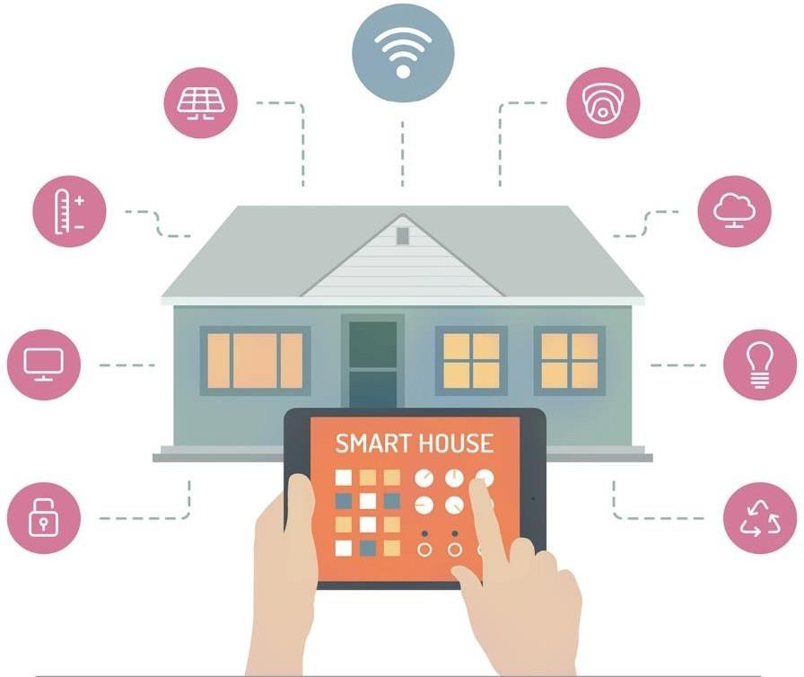

*Figure 1(a): Home Automation Systems*

Home automation refers to the use of technology to automate and control various aspects of a home, such as lighting, heating, and security. The need for home automation has increased in recent years due to the convenience and energy-saving benefits it offers.

Overall, while home automation offers many benefits, it also presents a number of challenges that need to be carefully considered before implementing it.

Some key benefits of home automation include:

1. Increased convenience: Home automation allows homeowners to control various aspects of their home from a single device, such as a smartphone or tablet, making it easier and more convenient to manage tasks and processes.
2. Improved energy efficiency: Home automation can help to reduce energy consumption by automatically turning off lights and appliances when they are not in use, saving homeowners money on their energy bills.
3. Enhanced security: Home automation systems can be integrated with security cameras and alarms, providing homeowners with peace of mind and added security for their home.
4. Improved accessibility: Home automation can help to make homes more accessible for individuals with disabilities or mobility challenges, allowing them to control various aspects of their home with ease.

The specific domain taken up by our team is *Gardening***.**



*Figure 1(b): Gardening*

One of the main challenges of domestic gardening is the time and effort required to maintain a healthy and attractive garden. Gardening can be labour-intensive, especially for those who are busy or have limited physical abilities.

Another challenge is the variability of weather conditions, which can affect the growth and health of plants. Extreme temperatures, drought, and other weather events can damage or kill plants, requiring constant monitoring and intervention.

Another challenge is the need for specialized knowledge and skills to successfully grow and care for plants. Not everyone has the knowledge and expertise to choose the right plants for their climate and conditions, and to provide the necessary care and attention.

Automation in gardening can help to address these challenges by allowing for remote control and monitoring of gardening tasks. Automated systems can provide automated watering, fertilizing, and other essential tasks, reducing the time and effort required for gardening.

Automation can also help to optimize gardening conditions by monitoring weather conditions and providing timely interventions to protect plants from damage. Additionally, automated systems can provide personalized recommendations and advice based on the specific needs of plants and gardens.

Overall, automation in gardening can help to make the hobby more accessible and enjoyable for those with busy lifestyles or limited gardening knowledge and skills.

# 2. Identifying the systematic design process to be followed.

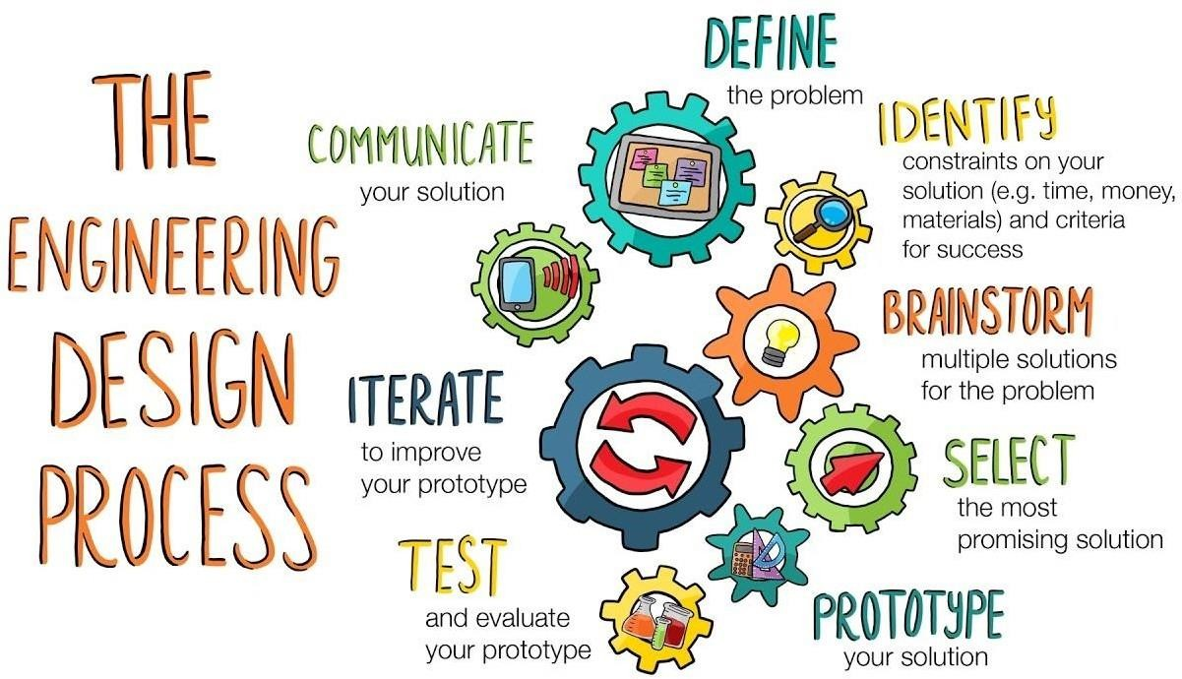

*Figure 2(a): Engineering Design Process*

The ***engineering design process*** is a methodical series of steps that engineers follow to come up with a solution to a problem. It is typically an iterative process, with designers making multiple prototypes and refining their designs based on feedback and testing.

The engineering design process also helps to foster creativity and innovation. By following a structured process, engineers can generate a wide range of potential solutions and evaluate them based on their feasibility and potential impact. This allows engineers to come up with creative and novel solutions that may not have been considered otherwise.

Additionally, the engineering design process helps to ensure that solutions are safe, ethical, and sustainable. Throughout the design process, engineers consider safety, environmental, and ethical considerations to ensure that the final solution is not only effective, but also responsible and sustainable.

Some key benefits of using the engineering design process include:

1. Improved problem-solving skills: The engineering design process encourages critical thinking and creativity, helping engineers to develop better problem-solving skills.
2. More efficient and effective solutions: By following a structured approach, engineers can generate a wide range of potential solutions and evaluate them based on specific criteria, ensuring that the chosen solution is the most effective and efficient.
3. Enhanced communication and collaboration: The engineering design process promotes collaboration among team members and encourages clear communication, helping to ensure that all stakeholders are on the same page and working towards a common goal.
4. Better decision-making: The engineering design process provides a systematic approach for evaluating potential solutions and making informed decisions, leading to better outcomes and improved project success.

The steps in the engineering design process typically include:

1. Define the problem: The first step in the engineering design process is to clearly define the problem or challenge that needs to be addressed. This involves identifying the specific needs and requirements of the project, as well as any constraints or limitations.
2. Generate potential solutions: Once the problem has been defined, the next step is to generate a range of potential solutions that could address the problem. This may involve brainstorming sessions, research, or other forms of idea generation.
3. Evaluate potential solutions: The next step is to evaluate the potential solutions based on specific criteria and constraints. This may involve conducting research, testing prototypes, or using mathematical or computational modelling to evaluate the feasibility and effectiveness of each solution.
4. Select the most appropriate solution: After evaluating the potential solutions, the next step is to select the most appropriate solution based on the criteria and constraints. This decision may be made by the team, or it may involve consultation with stakeholders or other experts.
5. Develop a plan: Once the solution has been selected, the next step is to develop a plan for implementing the solution. This may involve creating detailed design drawings, specifications, and other documents that outline the steps and resources needed to implement the solution.
6. Implement and test the solution: The final step in the engineering design process is to implement and test the chosen solution. This may involve building and testing prototypes, conducting experiments, or conducting other forms of validation to ensure that the solution meets the needs and requirements of the project.

### General Flow of Engineering Design Process:

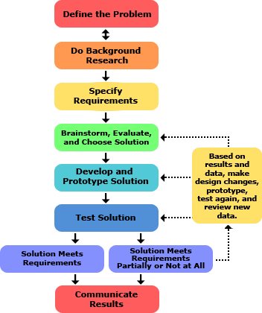

*Figure 2(b): Flow of Engineering Design Process*

Overall, the engineering design process is an important tool for engineers to systematically and effectively solve problems. It allows designers to systematically explore a variety of solutions, test their feasibility and effectiveness, and ultimately create a final design that meets the needs of the problem.

# Planning & Task Clarification

(Planning, identifying users, collecting need statements, and generating initial problem statement)

This phase of product development is crucial as all the planning, identification of users, understanding the need of the users, and generating an initial problem statement that helps in directing the design toward one that solves the problem of the users, is understood and documented.

There are multiple steps that are followed to get the required data that will allow the development of the solution to start.



### Planning & Scheduling:

*Fig 3.a Planning*

In this step, all the tasks that need to be done are listed and a timeline is put down so that the Agile methodology can be used in conjunction with design thinking and engineering design to create independent tasks that can be accomplished in sprints.

The following steps are followed in design thinking:

#### Identification of users and creating user stories:

In this step, the team members approach people that could help them better understand the problem that the team has decided to solve.

After interacting with many people, users are identified. There are people that are really in need of a solution to the problem and are willing to help the team by giving a description of the problem and how it is affecting their quality of life.

Following are the user stories that were generated after identifying users:

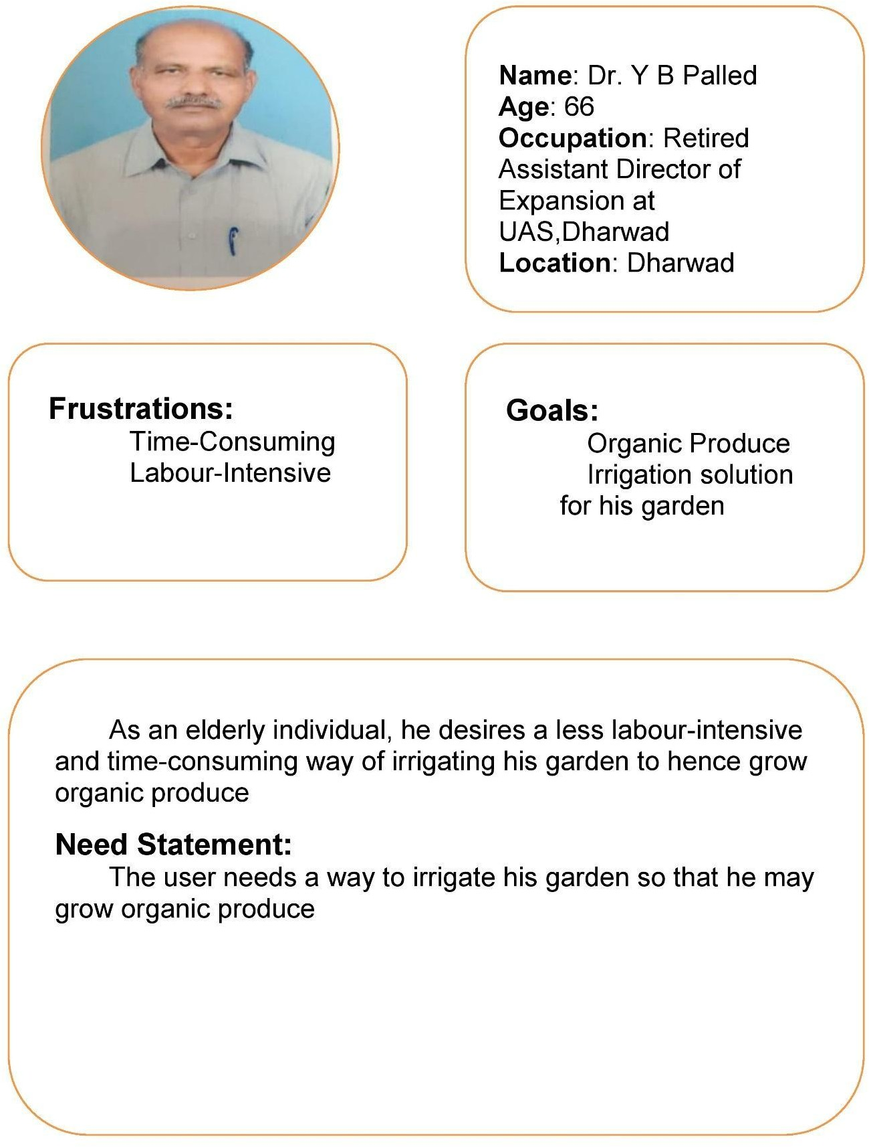

*Fig 3.1.a User Persona 1*

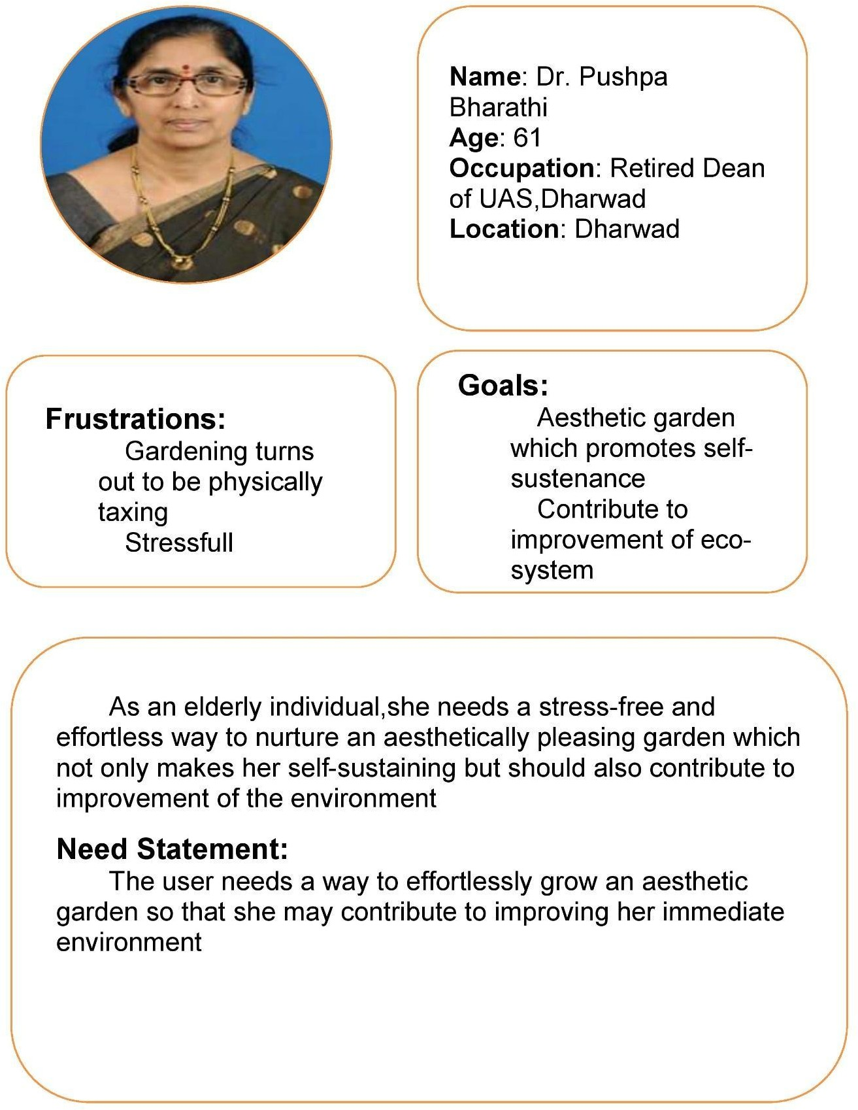

*Fig 3.1.b User Persona 2*

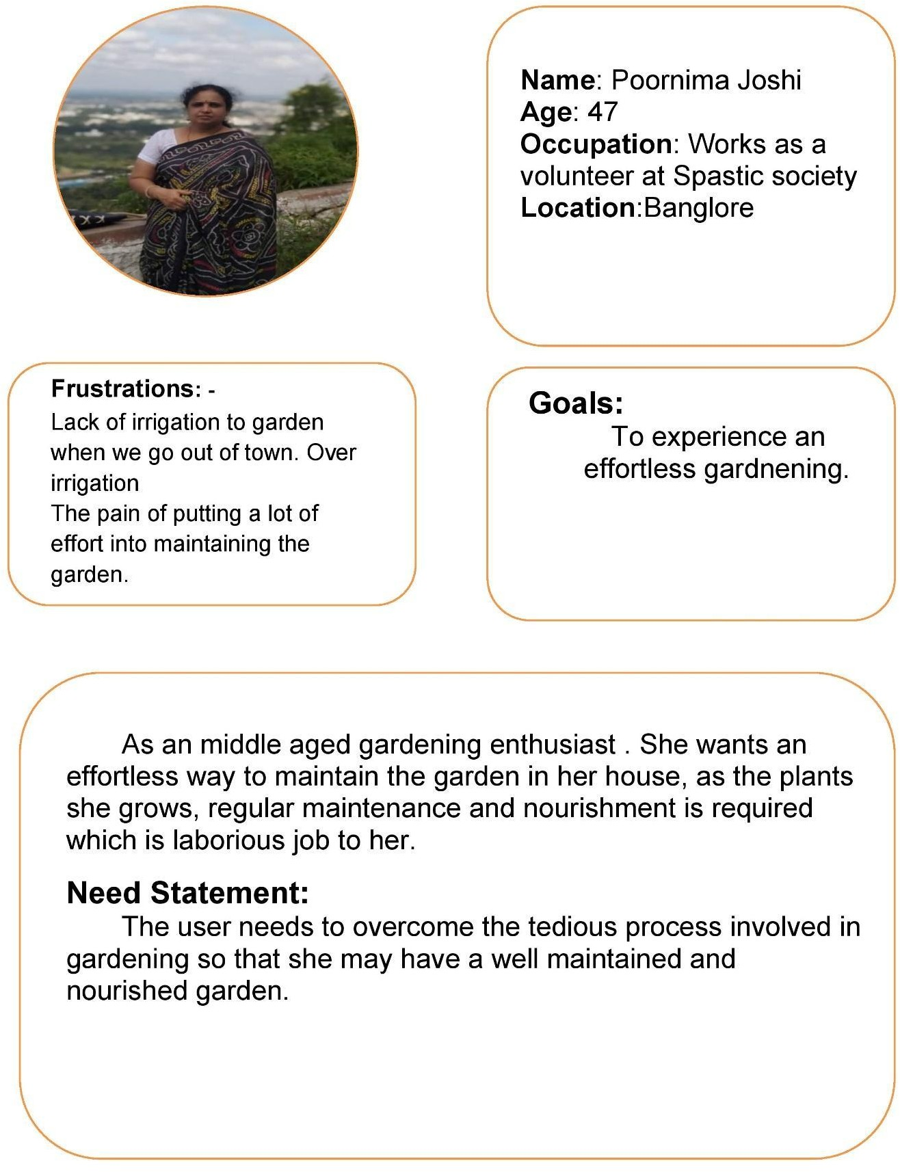

*Fig 3.1.c User Persona 3*

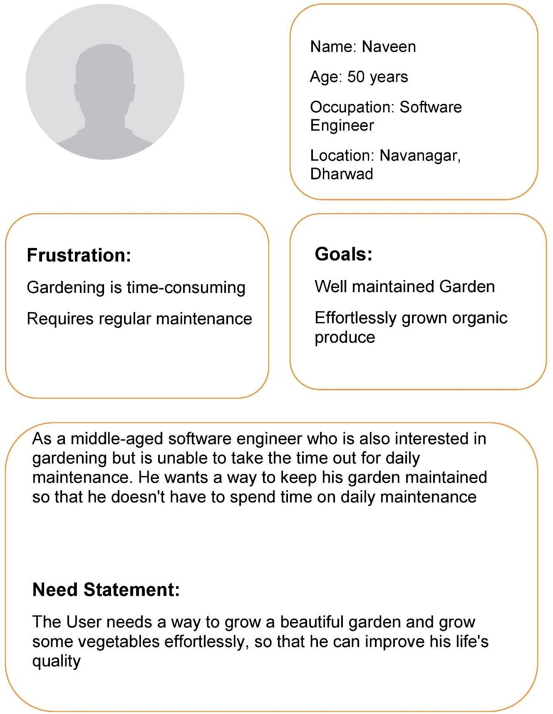

*Fig 3.1.d User Persona 4*

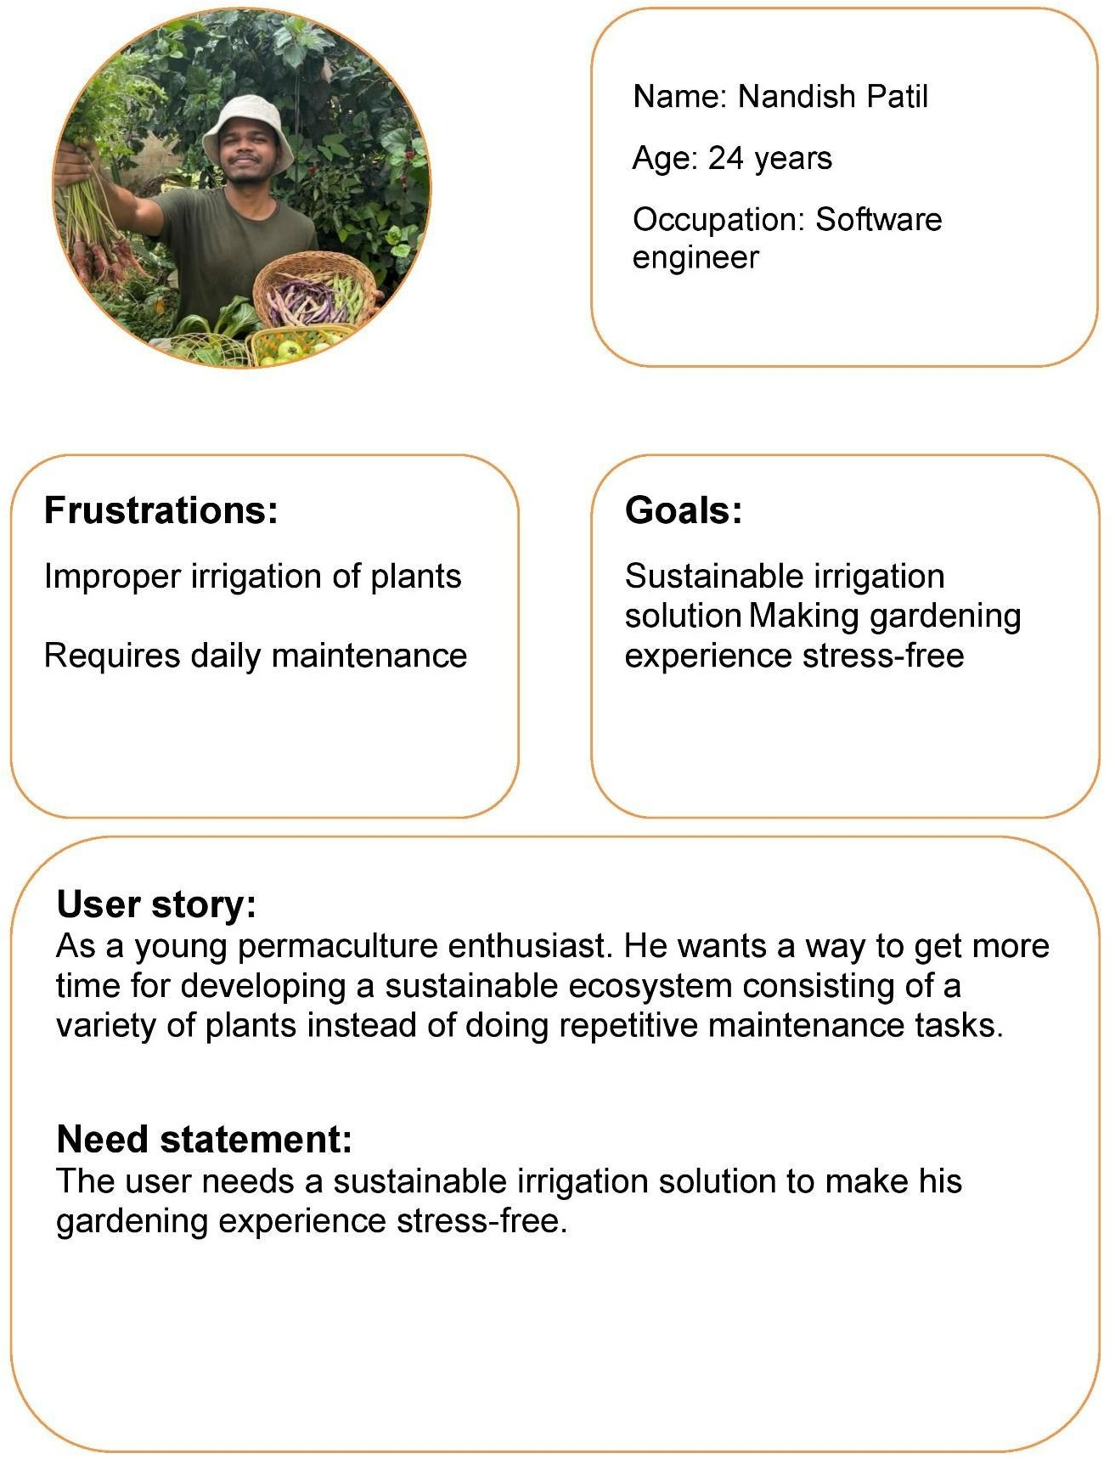

*Fig 3.1.e User Persona 5*

#### Empathy map:

By looking at these user stories an empathy map is created which helps the team empathize with the user’s situation

The empathy map consists of these sections’ pains, gains, thinks & feels, sees, and hears all these sections together give us an understanding of the user’s situation. It is essential to understand the user’s situation or the environment they live in so that the product or solution that is being designed can best fit their needs.

Below is the picture of the empathy map that was created after going through the user stories:

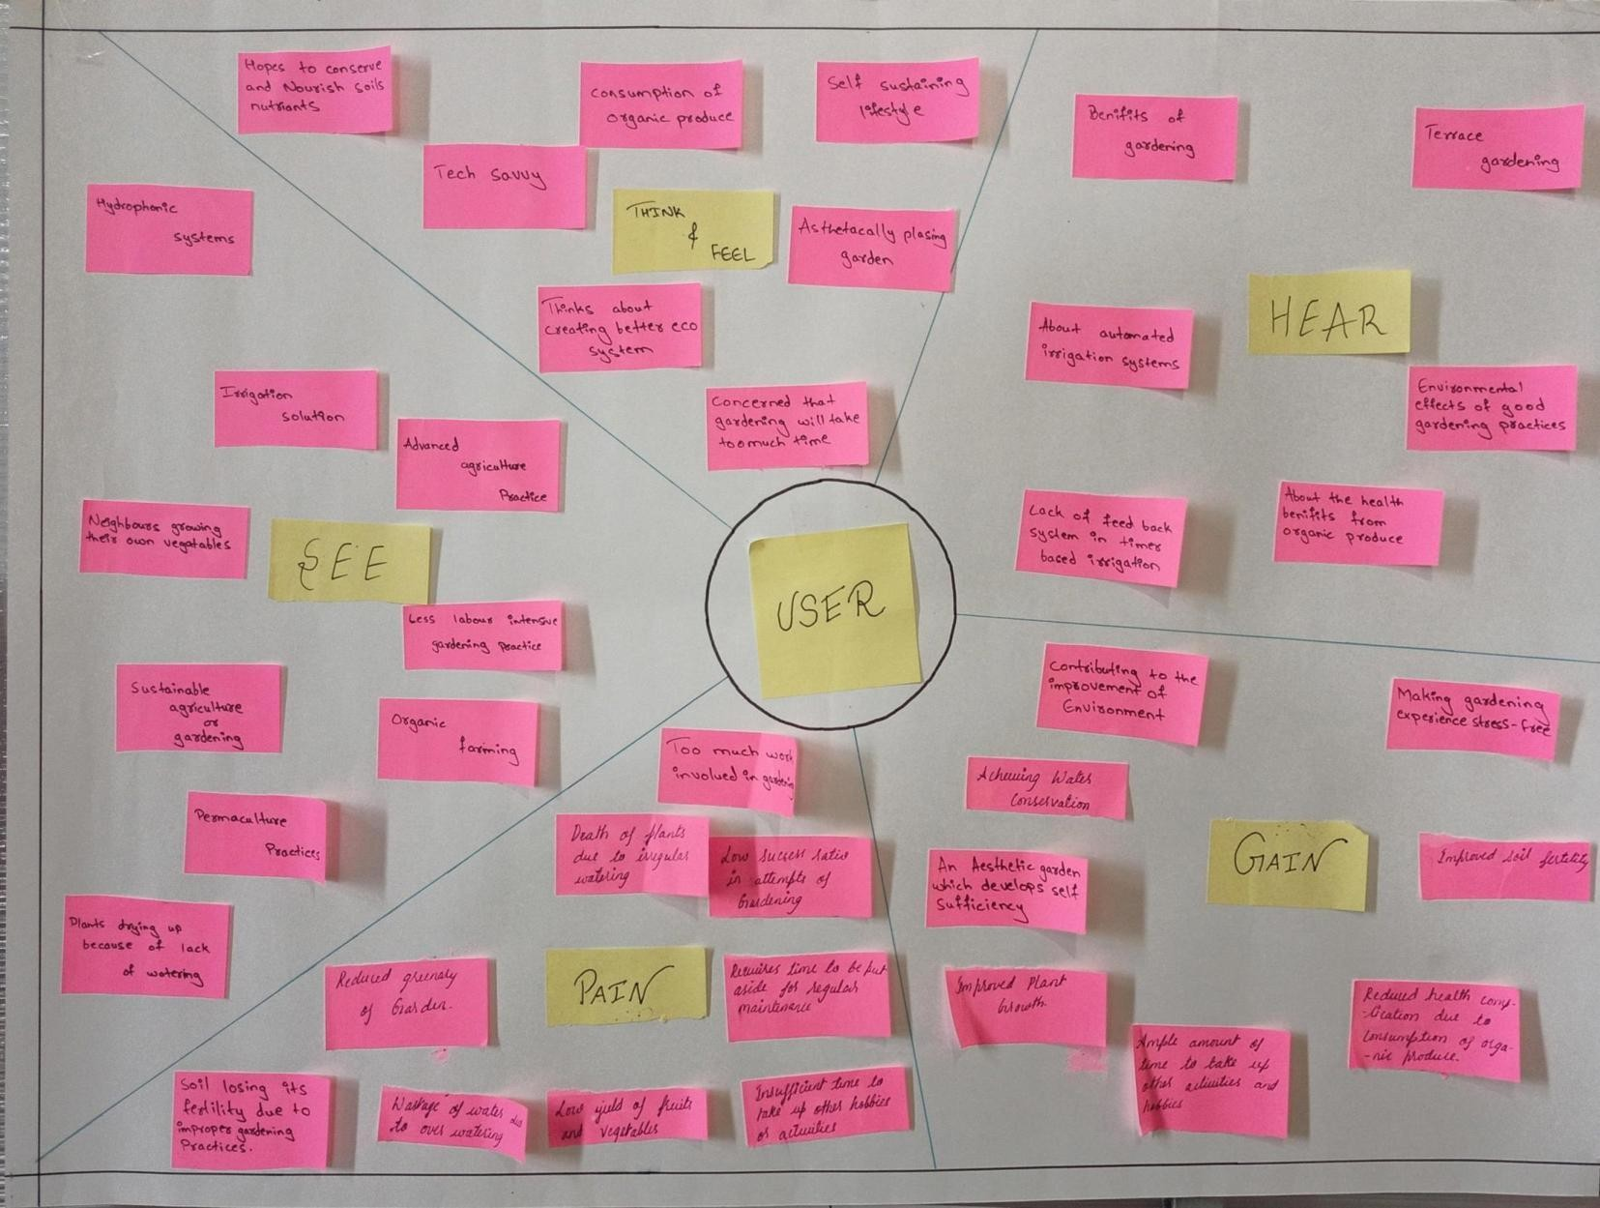

*Fig 3.1.f Empathy Map*

#### User stories:

The next step in design thinking is to create user stories that only address one point so that they can be prioritized and worked on. These user stories address all the entities that are going to be interacting with the solution or product that includes the end users as well as entities that are involved in the transportation, repair, installation, sales, and customer care.

Multiple aspects of the product need to be addressed so that the customers find value in the product or solution. In order to address all the aspects of the product or solution the user stories with their acceptance criteria are split up into reach, acquisition, activation, retention, and loyalty.

Below are the user stories: Reach: -

US-01: Cost: -

While searching for a solution the users need a cost-effective solution that is financially viable for them.

Acceptance criteria:

When the user goes to buy the product Then they must find the product to be cost-effective.

US-02: Aesthetic features: -

While looking for a solution the user needs the solution to be aesthetically pleasing so that it improves the overall aesthetic of the garden.

Acceptance criteria:

When the user looks at the product Then they must find the product aesthetically pleasing.

US-03: Product packaging: -

While looking for a solution the user needs it to be packaged well so that the product is delivered undamaged.

Acceptance criteria:

When the user observes the packaging of the product Then they must find the packaging sturdy and the product undamaged.

US-04. More features compared to other competitors: -

While looking for a solution, the user needs the product to have more features compared to its competitors so choosing the product turns out to be beneficial for them

Acceptance criteria:

When the user compares the product to other solutions then the user must find the product to be more endowed with features.

US-05. Satisfy the user’s basic needs: -

While looking for a solution, the user needs the product to satisfy their basic requirements so that their needs are fulfilled.

Acceptance criteria:

When the user utilizes the product then their basic need should be fulfilled

Acquisition: -

US-06: Build quality: -

The user while acquiring the product needs it to have a sturdy build quality so that it can withstand heavy /rough usage.

Acceptance criteria:

When the user goes to buy the product, then it must have good build quality.

US-07: Handy to use/Ergonomic: -

The user needs it to be ergonomic so that it is handy to use. Acceptance criteria:

When the user goes to buy the product Then the product must have good ergonomics.

US-08: Can be used in various situations: -

The user needs a versatile solution so that it can be used in various applications

Acceptance criteria:

When the user goes to buy the product Then the product must be versatile in nature.

US-09: Compact:

The user needs a compact solution so that it does not take up too much space in their gardens.

Acceptance criteria:

When the user installs the product in their garden then it must take up less space.

US - 10: Capability: -

The User needs the product to have the capability to perform its intended functionality so that the user’s initial requirement is fulfilled.

Acceptance criteria:

When the product begins operation then it must be able to perform its expected functionality.

US - 11: Modularity: -

The user needs the product to be modular so that the parts can be easily replaced, should something go wrong.

Acceptance criteria:

When a component in the product is faulty then it needs to be easy to replace.

Activation: -

US -12: Easy installation

After Acquiring the product, the user needs the product to be easy to install so that it is easy to accommodate in their existing garden. Acceptance criteria:

When the user buys the product Then the product must be easy to install.

US - 13: Easy to use

After Acquiring the product, the user needs the product to be easy to use so that it can be used effortlessly.

Acceptance criteria:

When the user buys the product Then the product must be easy to use/operate.

US - 14: Easy to understand the user manual: -

After Acquiring the product, the user needs the user manual to be easily understood so that they can use the product properly.

Acceptance criteria:

When the user buys the product Then the user manual must be easy to understand.

Retention: -

US - 15: Reliable operation

While using the product, the users need the product to be reliable so that it does not intervene with their daily routines.

Acceptance criteria:

When the user uses the product Then the product should not disturb their daily routines.

US - 16: Less human interaction/Automatic: -

While using the product, the user needs the product to require minimal interaction so that they can focus on other activities. Acceptance criteria:

When the user uses the product Then the product must require minimal human interaction.

US - 17: Conservation of resources: -

While using the product, the user needs the product to work effectively so that it conserves their overall resources.

Acceptance criteria:

When the user uses the product Then the product must utilize minimal resources (Time, Water, & Money).

US - 18: Less maintenance: -

While using the product, the user needs the product to require less maintenance so that they don't have to regularly put in service requests.

Acceptance criteria:

When the user uses the product Then the product must require minimal maintenance.

Loyalty: -

US - 19: Good customer service: -

After having used the product for a prolonged time, the user needs the product to have good customer service so that they receive regular assistance on queries related to their product.

Acceptance criteria:

When the user has a query regarding the product Then the necessary customer service must be provided.

US - 20: regular maintenance: -

After having used the product for a prolonged time, the user needs the product to undergo regular maintenance so that it functions ideally throughout its operating lifespan.

Acceptance criteria:

When the product is being utilized by the user Then the product must be regularly maintained so as to avoid faults in the product.

US - 21: Regular upgrades to the product: -

After having used the product for a prolonged time, the user needs the product to have regular upgrades so that it stays up-to-date so as meet the users’ needs.

Acceptance criteria:

When the product is being used by the user Then the product must receive regular upgrades so as to meet the users’ requirements effectively.

#### Categorizations into demands and desires

The user stories are sorted into two categories demands and desires. The demands are usually the basic needs of the users, and the product or solution must satisfy them. Desires are usually luxuries that make interacting with the product or solution a pleasant experience.

Below is the list of demands and desires:-

*Table No. 3.1.a Demands and Desire*

|  |  |
| --- | --- |
| Demand | Desire |
| US - 01 | US - 02 |
| US - 03 | US - 04 |
| US - 05 | US - 07 |
| US - 06 | US - 08 |
| US - 09 | US - 13 |
| US - 10 | US - 16 |
| US - 11 | US - 21 |
| US - 12 |  |
| US - 14 |  |
| US - 15 |  |
| US - 17 |  |
| US - 18 |  |
| US - 19 |  |
| US - 20 |  |

#### Requirement generation:

In this phase the user stories are converted into requirements this is done by evaluating the acceptance criteria in each of the user stories. In addition to user stories, acceptance criteria can also be used as a tool to generate requirements for a system. Acceptance criteria are specific, measurable, and testable conditions that a system must meet in order to be considered "done" or ready for acceptance. These criteria are typically derived from the user stories and provide a clear and objective way to determine whether the system meets the requirements of the end user.

To generate requirements from user stories using acceptance criteria, the first step is to identify the specific goals or actions that the user wants to achieve, as described in the user stories. Once these goals or actions have been identified, the next step is to define acceptance criteria that describe the conditions that must be met in order for the system to be considered ready for acceptance. For example, if the user story is "As a customer, I want to be able to purchase products online so that I can shop from the convenience of my own home," the acceptance criteria might include:

The system must have a secure payment system.

The system must have a catalogue of available products. The system must have the ability to track and fulfill orders. The system must be easy to use and navigate.

These acceptance criteria can then be used as the basis for generating the specific requirements that are needed to support the goals and actions described in the user stories. In addition to providing a clear and objective way to determine whether the system is ready for acceptance, the use of acceptance criteria can also help to ensure that the system being developed meets the needs of the end user and supports the desired functionality.

*Table No. 3.1.b Requirement generation*

|  |  |  |
| --- | --- | --- |
| R.No | Source | Requirement |
| 1 | Survey | The price should be less than 10000 Rs |
| 2 | Team | Should be priced at less than 15% of competitors |
| 3 | Client | No Compromises must be made in the build quality due to low pricing |
| 4 | Client | Smooth surface finish |
| 5 | Client | Glossy appearance |
| 6 | Client | The product should have Unique colors |
| 7 | Team | The product must consist of a unique Geometry |
| 8 | Survey | Packaging should withstand any situations |
| 9 | Team | Packaging should handle at least 4ft. fall without causing any damage to the product |
| 10 | Team | Easy to hold and move by a single person |
| 11 | Survey | Packaging should be light in weight & cost-effective |
| 12 | Team | Should be easy to Carry/Handle |
| 13 | Team | Should have no sharp edges and should be child-friendly |
| 14 | Survey | Should not cost more than 10000 Rs |
| 15 | Team | Should cost 10% less than its competitors |
| 16 | Team | Should conserve at least 15% fewer resources compared to competitors |
| 17 | Client | Safe to use |
| 18 | Client | Should Work in required Conditions |
| 19 | Team | The product should withstand heavy/rough usage |
| 20 | Team | The product should be made up of good-quality materials |
| 21 | Team | The product should at least handle a 3 ft fall without any substantial damage |
| 22 | Survey | Should be easy to hold |
| 23 | Survey | Should have minimal sharp edges |
| 24 | Team | Should be installable in any garden |
| 25 | Survey | Suitable for smaller gardens |
| 26 | Survey | Size should be less than 2 cubic feet |
| 27 | Team | Maintains Moisture level of soil |

|  |  |  |
| --- | --- | --- |
| 28 | Client | Aids in the growth of plants |
| 29 | Client | Consumes fewer resources |
| 30 | Team | Replacement parts should be readily available |

* + 1. Requirements are classified based on metrics, these metrics can be used to measure the success of the project, and to determine if the requirements have been adequately met. Additionally, metrics can be used to prioritize requirements, with higher-importance requirements having more stringent metrics, and lower-importance requirements having less stringent metrics.

The below table is created which categorizes the requirements: -

*Table 3.1.c Requirement categorization*

|  |  |  |  |  |
| --- | --- | --- | --- | --- |
|  | Requirement | Importance | D/W | Category |
|  | The price should be less than 10000 Rs | 4 | Deman d | Cost |
|  | Should be priced at less than 15% of competitors | 4 | Deman d | Cost |
|  | No Compromises must be made in the build quality due to low pricing | 7 | Deman d | Quality Control |
|  | Smooth surface finish | 5 | Wish | Material |
|  | Glossy appearance | 5 | Wish | Material |
|  | The product should have stand-out colours | 5 | Wish | Material |
|  | The product must consist of a unique geometry | 5 | Wish | Geometry |
|  | Packaging should withstand any situations | 5 | Deman d | Transport |
|  | Packaging should handle at least 4ft. fall without causing any damage to the product | 5 | Deman d | Transport |
|  | Easy to hold and moved along by a single person | 5 | Deman d | Transport |
|  | Packaging should be light in weight & cost-effective | 5 | Deman d | Transport |
|  | Should be easy to Carry/Handle | 6 | Wish | Ergonomic |
|  | Should have no sharp edges and should be child-friendly | 10 | Wish | Safety |

|  |  |  |  |  |
| --- | --- | --- | --- | --- |
|  | Should not cost more than 10000 Rs | 4 | Wish | Cost |
|  | Should cost 10% less than its competitors | 4 | Wish | Cost |
|  | Should conserve at least 15% less overall resources compared to competitors | 7 | Wish | Energy |
|  | Safe to use | 10 | Deman d | Safety |
|  | Should Work in required Conditions | 7 | Deman d | Operation |
|  | The product should withstand heavy/rough usage | 6 | Deman d | Ergonomic |
|  | The product should be made up of good-quality materials | 5 | Deman d | Materials |
|  | The product should at least handle a 3 ft fall without any substantial damage | 7 | Deman d | Quality Control |
|  | Should be easy to hold | 6 | Wish | Ergonomic |
|  | Should have minimal sharp edges | 6 | Wish | Ergonomic |
|  | Should be installable in any garden | 6 | Wish | Ergonomic |
|  | Suitable for smaller gardens | 7 | Deman d | Operation |
|  | Size should be less than 2 cubic feet | 5 | Deman d | Geometry |
|  | Maintains Moisture level of soil | 7 | Deman d | Operation |
|  | Aids in the growth of plants | 7 | Deman d | Operation |
|  | Consumes fewer resources | 7 | Deman d | Energy |
|  | Parts should be readily available | 5 | Deman d | Maintenance |
|  | Parts should be easily detached | 5 | Deman d | Assembly |
|  | Parts should be reasonably priced | 4 | Deman d | Cost |
|  | Should have standard attachment brackets | 5 | Deman d | Geometry |
|  | Should use fewer fasteners | 6 | Deman d | Assembly |

|  |  |  |  |  |
| --- | --- | --- | --- | --- |
|  | A technician with a medium level of expertise should be able to install it | 5 | Deman d | Assembly |
|  | Installation should not take more than 2 hrs | 6 | Deman d | Assembly |
|  | Should be installable by general tools | 6 | Deman d | Assembly |
|  | No requirement of any platform base for installation | 6 | Deman d | Assembly |
|  | Should require less than 5 user inputs to operate | 7 | Wish | Operation |
|  | The user interface should not be complicated so that it can be used by a variety of age groups | 7 | Wish | Operation |
|  | There should be a set of simple instructions for maintenance | 5 | Wish | Maintenance |
|  | The user’s manual should not be more than 10 pages | 5 | Wish | Maintenance |
|  | The manual should contain mostly pictorial representations of the instructions | 5 | Wish | Maintenance |
|  | The manual should be available in the form of paperback as well as online | 7 | Wish | Ease of use |
|  | Textual content should be in English as well as in the regional language | 7 | Wish | Ease of use |
|  | The user should have less than two or three interactions per day | 7 | Deman d | Operation |
|  | The interactions should not take more than 10 min of the user’s time | 7 | Deman d | Operation |
|  | The product should require minimal interaction | 7 | Wish | Operation |
|  | The product should not interfere with their schedule | 7 | Wish | Operation |
|  | At least 10% of water must be saved | 7 | Deman d | Energy |
|  | Must consume less than 5kWatt/hr per month | 7 | Deman d | Energy |
|  | Must require less than 2 hours to perform the operation | 9 | Deman d | Time |

|  |  |  |  |  |
| --- | --- | --- | --- | --- |
|  | Shouldn't breakdown often | 7 | Deman d | Schedule |
|  | Facilitate simple maintenance | 5 | Deman d | Maintenance |
|  | Provide long intervals between alternate maintenance schedules | 7 | Deman d | Schedule |
|  | The user manual must be efficient to help the customer perform self-maintenance | 5 | Deman d | Maintenance |
|  | The customer query must be responded to within 24 hrs | 9 | Deman d | Time |
|  | Customer service is to be provided in English and regional languages | 6 | Deman d | Simple understanding |
|  | Maintenance services Should be provided by the company | 5 | Deman d | Maintenance |
|  | Pocket-friendly maintenance | 4 | Deman d | Cost |
|  | Receive regular updates | 7 | Wish | Schedule |
|  | New upgrades solving additional problems | 7 | Wish | Operation |
|  | The product should be remotely controllable | 7 | Wish | Ease of use |
|  | Should notify the user when various tasks are completed | 7 | Wish | Operation |
|  | Should provide statistical data to the user | 7 | Deman d | Operation |
|  | There should be safety mechanisms in place so that the components don't get damaged | 10 | Deman d | Safety |
|  | The product should be moderately water resistant. | 6 | Deman d | Assembly |
|  | The product should display the status of an operation | 7 | Wish | Operation |

### Final problem statement:

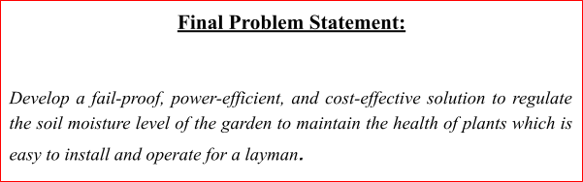

*Fig 3.2.a Final Problem statement*

### : Competitive benchmarking:

Competitive benchmarking is the process of comparing products, processes, or services to those of its competitors in order to identify areas for improvement. This can help develop more competitive products, processes, or services, and identify opportunities for innovation. To conduct competitive benchmarking, key competitors are identified and information is gathered about their offerings. This information is then used to compare the products, processes, or services being developed to those of its competitors, and to identify areas where it can improve. The results of the competitive benchmarking process can inform product development decisions and help a develop a competitive product.

These are the steps that are followed to do competitive benchmarking:- The affinity groups are identified:

*Table 3.3.a Affinity groups*

|  |  |  |
| --- | --- | --- |
| R No. | Sub-Category 1 | Category |
| 1 | Maximum Retail Price | Cost |
| 2 | Competitive Pricing | Cost |
| 3 | Uncompromised Build | Quality Control |
| 4 | Texture | Material |
| 5 | Texture | Material |
| 6 | Colour | Material |
| 7 | Design | Geometry |
| 8 | Package | Transport |
| 9 | Ergonomics | Transport |
| 10 | Package | Transport |

|  |  |  |
| --- | --- | --- |
| 11 | Package | Transport |
| 12 | Handling | Ergonomic |
| 13 | Design | Safety |
| 14 | MRP | Cost |
| 15 | Competitive Pricing | Cost |
| 16 | Resource management | Energy |
| 17 | Safe operation | Safety |
| 18 | Reliability | Operation |
| 19 | Build quality | Ergonomic |
| 20 | Material properties | Materials |
| 21 | Build quality | Quality Control |
| 22 | Handling | Ergonomic |
| 23 | Design | Ergonomic |
| 24 | Compatibility | Ergonomic |
| 25 | Compatibility | Operation |
| 26 | Design | Geometry |
| 27 | Regulation | Operation |
| 28 | Commensalism | Operation |
| 29 | Resource management | Energy |
| 30 | Availability | Maintenance |
| 31 | Modularity | Assembly |
| 32 | Pricing | Cost |
| 33 | Modularity | Geometry |
| 34 | Resource management | Assembly |
| 35 | Installation | Assembly |
| 36 | time management | Assembly |
| 37 | Installation | Assembly |
| 38 | Installation | Assembly |
| 39 | Inputs | Operation |
| 40 | Operability | Operation |
| 41 | Instructions | Maintenance |
| 42 | Resource management | Maintenance |
| 43 | Pictorial representation | Maintenance |
| 44 | Availability | Maintenance |
| 45 | Lucid | Ease of use |

|  |  |  |
| --- | --- | --- |
| 46 | Interactions | Ease of use |
| 47 | time management | Operation |
| 48 | Interactions | Operation |
| 49 | Time management | Operation |
| 50 | Resource management | Energy |
| 51 | Resource management | Energy |
| 52 | Time management | Time |
| 53 | Reliability | Schedule |
| 54 | Lucid | Maintenance |
| 55 | Service internal | Schedule |
| 56 | User manual | Maintenance |
| 57 | Customer Service | Time |
| 58 | Customer Service | Simple understanding |
| 59 | Customer Service | Maintenance |
| 60 | maintenance cost | Cost |
| 61 | Updates | Schedule |
| 62 | Upgrades | Operation |
| 63 | Control | Ease of use |
| 64 | Notification | Operation |
| 65 | Data presentation | Operation |
| 66 | Component management | Safety |
| 67 | Water resistances | Assembly |
| 68 | Notification | Operation |

Then the user stories are categorized under the metrics:

*Table 3.3.b Metric categorization*

|  |  |  |  |
| --- | --- | --- | --- |
| Metric Number | Requirement Number | Metric | Units |
| 1 | 1,2,14,15,32,60 | Cost | Indian Rupees |
| 2 | 3,21 | Quality |  |
| 3 | 4,5,6,20 | Material |  |
| 4 | 7,26,33 | Geometry | mm^3, mm |
| 5 | 8,9,10,11 | Transport |  |
| 6 | 12,22,24,23,19 | Ergonomics | mm |
| 7 | 13,17,66 | Safety | Safety factor |
| 8 | 16,29,50,51 | Energy | Voltage, Litres, kWh |
| 9 | 18,25,27,28,39,40,46,47,48,49,62,64,75,68 | Operation |  |
| 10 | 30,41,42,43,54,56,59 | Maintenance | Days and Instances |
| 11 | 31,34,35,36,37,38,67 | Assembly | Hours |
| 12 | 44,45,63 | Ease of use |  |
| 13 | 52,57 | Time | Hours |
| 14 | 53,55,61 | Schedule | Days/months |
| 15 | 58 | Simple understanding |  |

Then the competitive benchmarking table is created:

*Table 3.3.c Competitive benchmarking*

|  |  |  |  |  |  |  |  |
| --- | --- | --- | --- | --- | --- | --- | --- |
| D S  No. | Requirement Number | Metric | Importance | Units | Margin al value | Ideal value | Validation/Test Method |
| 1 | 1,2,14,15,32,  60 | Cost | 4 | Indian Rupees | 5,000  Rs | 10,000  Rs | Quotation |
| 2 | 3,21 | Quality | 7 |  |  |  | Quality control, Stress analysis, and drop testing |
| 3 | 4,5,6,20 | Material | 5 |  |  |  | Material testing |
| 4 | 7,26,33 | Geometry | 5 | mm^3, mm | 350  mm^3 | 200  mm^3 | Drafts |
| 5 | 8,9,10,11 | Transport | 5 |  |  |  | Transport quotation |
| 6 | 12,22,24,23,1  9 | Ergonomics | 6 | Mm, number of sharp edges | 2 sharp edges | 0 sharp edges | On hand comparison |
| 7 | 13,17,66 | Safety | 10 | Safety factor | More than 1.75 | More than 1.5 | Safety ratings |
| 8 | 16,29,50,51 | Energy | 7 | Voltage  , liters, KWh | 220v,  2 kWh per month | 220 v,  1Kwh per month | Energy ratings |
| 9 | 18,25,27,28,3  9,40,46,47,48  ,49,62,64,65,  68 | Operation | 7 |  |  |  | On-site performance review |
| 10 | 30,41,42,43,5  4,56,59 | Maintenance | 5 | Days and Instanc es | 1  month | 1 month | User review |
| 11 | 31,34,35,36,3  7,38,67 | Assembly | 6 | Hours | 2 hours | 1 hour | User review |

|  |  |  |  |  |  |  |  |
| --- | --- | --- | --- | --- | --- | --- | --- |
| 12 | 44,45,63 | Ease of use | 7 |  | 10  steps to operate | 6 steps to operate | Handling |
| 13 | 52,57 | Time | 9 | Minute s | 15 to 20 minutes | 5 to 10 minutes | Time Logging |
| 14 | 53,55,61 | Schedule | 7 | Days/ months | Once in 2  months | Once in 6  months | Statistical time data |
| 15 | 58 | Simple understandin g | 6 |  |  | Easy to underst and in 20 min | User review |

### Identify metrics to measure success:

The metrics to measure the success of the product or solution are given by the acceptance criteria in the user stories most of the acceptance criteria can be quantified and then measured.

Most of the functional requirements are also quantifiable which means that they can be measured. Measurement of these metrics after the development of the product can give an understanding of whether the product or solution is up to the mark.

Below are the metrics that are used to measure the success of the irrigation system:

*Table 3.4.a Measurement metrics*

|  |
| --- |
| Metric |
| Cost |
| Quality |
| Material |
| Geometry |
| Transport |
| Ergonomics |
| Safety |
| Energy |
| Operation |
| Maintenance |

|  |
| --- |
| Assembly |
| Ease of use |
| Time |
| Schedule |
| Simple understanding |

### Design Specifications:

Design specifications are detailed documents that describe how a product, system, or process should be designed and developed. They provide clear and specific guidelines and requirements for designers and developers to follow in order to ensure that the final product meets the needs of the user or customer. Design specifications can include information on materials, dimensions, performance, functionality, and other technical details. They are typically created by engineers or other technical experts as part of the design process. Overall, design specifications help to ensure that a product or system is well-designed, functional, and meets the requirements of the user or customer.

*Table 3.5.a design specifications*

|  |  |
| --- | --- |
| Metric | Design specifications |
| Cost | cost price under 5,000 Rs |
| Quality | High Build quality with reliable components |
| Material | Acrylic |
| Geometry | under 350 mm^3 |
| Transport | Easy to transport |
| Ergonomics | 0 sharp edges |

|  |  |
| --- | --- |
| Safety | More than 1.75 safety factor |
| Energy | 220v,  2 kWh per month |
| Operation | Easy and reliable operation |
| Maintenance | once a month |
| Assembly | 2 hours |
| Ease of use | 10 steps to operate |
| Time | 15 to 20 minutes of operation |
| Schedule | Once in 2 months maintenance. |
| Simple understanding | Easy to understand and operate in 20 min |

# Conceptual Design

### Identification of essential problems – Revised problem statement

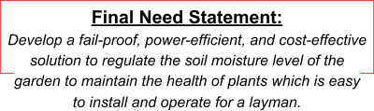

*Fig 4.a Revised problem statement*

### Identification of Overall function

Based on the requirements that are generated in the previous step the list of functions can be generated by analyzing the requirements list and that analysis, coupled to the following step-by-step abstraction, will reveal the general aspects and essential problems of the task, as follows:

Step 1. Eliminate personal preferences.

Step 2. Omit requirements that have no direct bearing on the function and the essential constraints.

Step 3. Transform quantitative into qualitative data and reduce them to essential statements.

Step 4. As far as it is purposeful, generalize the results of the previous step. Step 5. Formulate the problem in solution-neutral terms.

Result Of Step 1 and 2: Functions-

* + - 1. Installable in Gardens of varying shape, sizes and terrains
      2. Dimension< 2 cubic feet
      3. Irrigate the plants
      4. Regulates the moisture level in soil
      5. Should be resource-friendly
      6. Lucid installation instructions
      7. Easy to implement operation procedures
      8. No. of user’s interactions= less than 3 times a day
      9. Time required per interaction< 10 minutes 10.Energy Consumption <5kW/hr. per month 11.Operation time for each cycle<=2 hours 12.Should be remotely controllable 13.Should be Water-Resistant 14.Interactable user interface

Result Of Step 3.

Functions:

1. Regulate the moisture level in soil
2. Minimal size
3. Easy installation
4. Power-Efficient
5. Build quantity
6. Remote-controllable operations
7. Minimal interaction Result Of Step 4.

Functions:

1. Regulating the moisture level in soil to 20%-60%.
2. Conserve Electricity
3. Easy installation
4. Remotely-controllable operations
5. Operate in different geometries of garden
6. Should enable essential fail-safe systems in case of emergency.
   * 1. Detailed functional analysis – Establish function structures

The functions that are gained are then made abstract and are broken down as finely as possible into categories like Conversion of energy, Conversion of materials, Conversion of information this process is known as functional decomposition and is represented as the functional structure of the product. Abstract functions:

* + - 1. Regulate soil moisture level // Regulate
      2. Consume less power // Reduce
      3. Maintain
      4. Install effortlessly
      5. Operate

Functional structure diagram:

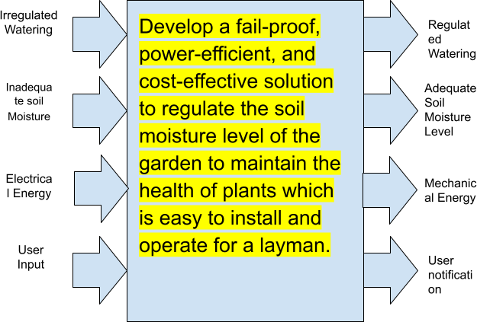

*Fig 4.b Function structure diagram*

Sub-functions based on function structure diagram: 1.Sensing Soil Moisture Level

* + - * + Changing Signals (Soil moisture input)
        + Connecting information with energy (Signal Conditioning)
        + Comparing Signals (Comparing the signal with ref) 2.Regulating Water Flow
        + Relocating matter (Accept water from main supply)
        + Connecting matter with energy (Pump water into supply lines)
        + Relocating matter(Guide water to necessary outlets)

1. Electricity consumption
   * Changing energy (step down, rectify, filter)
   * Connecting energy with information (controlling actuators when necessary)
   * Varying energy components (powering the control unit and other components)
2. User Interaction
   * Changing Signals(User input)
   * Connecting energy with information(Signal transmission to control unit)
   * Connecting information with energy (sending Instruction to sensing units)
   * Connecting information with matter (sending Instruction to water flow actuators)

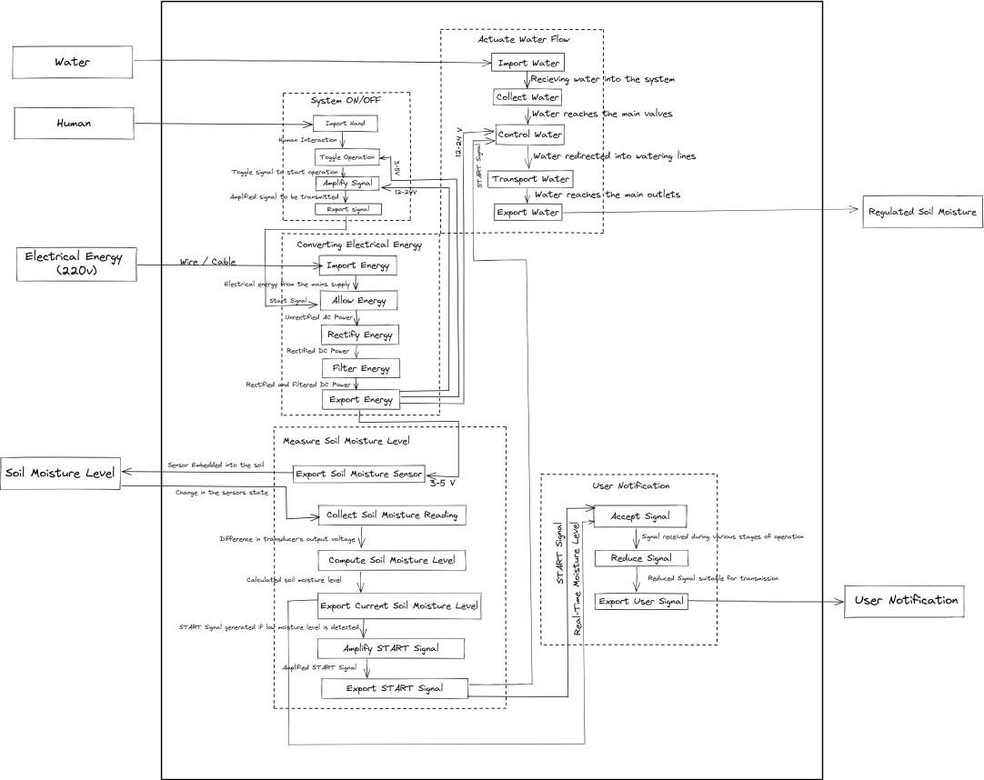The black box diagram:

*Fig 4.c The black box diagram*

The list of final subfunctions after generating the black box diagram:

*Table No. 4.a Function listing*

|  |  |
| --- | --- |
| **Sub Function Number** | **Sub Function** |
| 1 | Import Hand |
| 2 | Toggle operation |

|  |  |
| --- | --- |
| 3 | Amplify signal |
| 4 | Export signal |
| 5 | Import energy |
| 6 | Allow Energy |
| 7 | Rectify Energy |
| 8 | Filter Energy |
| 9 | Export Energy |
| q | Export soil moisture sensor |
| 11 | Collect soil moisture reading |
| 12 | Compute soil moisture level |
| 13 | Export current soil moisture level |
| 14 | Amplify start signal |
| 15 | Export start signal |
| 16 | Import water |
| 17 | Collect water |
| 18 | Control water |
| 19 | Transport water |
| 20 | Export water |
| 21 | Accept signal |
| 22 | Reduce signal |
| 23 | Export user signal |
| 24 | Controller |
| 25 | Casing |

* + 1. Search for working principles and working structures

A working principle comes into existence through physical effects in combination with the chosen geometric and material characteristics.

*Table No.4.b Working principle listing*

|  |  |  |  |
| --- | --- | --- | --- |
| **Sub-fun Number**  **.** | **Subfunction s** | **Physical effect** | **Working principle** |
| 1 | Import hand | Contact force [ R=sqrt(f^2 +N^2) ] | Physical Contact |

|  |  |  |  |
| --- | --- | --- | --- |
| 2 | Toggle operation | Contact force [ R=sqrt (f^2 +N^2) ] | Instruction  of controlled switches |
| 3 | Amplify signal | Amplification [Gain=1+ (Feedback Resistance/Ground Resistance)] | Amplificatio n of signals to required magnitude using transistors. |
| 4 | Export signal | Friis transmission equation [(Power of receiver/Power of receiver)=(Aperture of receiver*Aperture of transmitter/(distance^2)*(wavelength^2)  )] |  |
| 5 | Import energy | Ohms Rule [V=IR] |  |
| 6 | Allow Energy | Faraday's law of induction [Inducted Voltage=-(No of loops)*(Change in flux/Change in time)] | Potential energy difference |
| 7 | Rectify Energy | Rectification [DC Voltage=(2*AC Voltage)/pi] | Conversion of AC to DC |
| 8 | Filter Energy | Removal of imperfections in energy value | Impedance matching |
| 9 | Export energy | Ohms Rule [V=IR] |  |
| 10 | Export soil moisture sensor | Contact with the soil | Physical contact |
| 11 | Collect soil moisture reading | Change in sensing element which can be detected | Measuremen t of  di-electric permittivity using  capacitance |
| 12 | Compute soil moisture level | Application of relevant equations to get the moisture level | Generating a voltage proportional to the  di-electric permittivity |
| 13 | Export current soil | Signal transmission using suitable communication protocols | UART, USB, USART, I2C |

|  |  |  |  |
| --- | --- | --- | --- |
|  | moisture level |  |  |
| 14 | Amplify start signal | Increase the amplitude of signal | Amplificatio n of signals to the required magnitude using transistors. |
| 15 | Export START  Signal | Signal transmission using suitable communication protocols | UART, USB, USART, I2C |
| 16 | Import Water | Accept water |  |
| 17 | Receive water | Increasing the volume of water in the system | Steady flow of Newtonian liquids |
| 18 | Control water | Regulating the flow rate of water | Steady flow of Newtonian liquids, Bernoulli’s principle, Archimedes Principle |
| 19 | Transport water | Change in the flow rate | Steady flow of Newtonian liquids, Bernoulli’s principle, Archimedes Principle |
| 20 | Export water | Release of water | Steady flow of Newtonian liquids, Bernoulli’s principle, Archimedes Principle |

|  |  |  |  |
| --- | --- | --- | --- |
| 21 | Accept signal | Signal Collection using suitable communication protocols | UART, USB,  USART, and I2C |
| 22 | Reduce signal | Decrease the amplitude of the signal | Reduction of signals to required magnitude using clipper circuits. |
| 23 | Export user signal | Signal transmission using suitable communication protocols | UART, USB,  USART, and I2C |

#### Generating alternate solutions

*Table No. 4.c. Morphological Chart:*

|  |  |  |  |  |
| --- | --- | --- | --- | --- |
| **Subfunctio**  **ns** | **Means 1** | **Means 2** | **Means 3** | **Means 4** |
| Import hand |  |  |  |  |
| Toggle operation | **Push Button** | **Toggle switch** | **Infra-Red sensor** | s  **Touchscreen** |
| Amplify signal |  | **MOSFET** | **BJT** | **OPAMP** |

|  |  |  |  |  |
| --- | --- | --- | --- | --- |
| Export signal | **Copper cable** | **Bluetooth** |  | **SIM**  **Module** |
| Import energy | **Three way socket** | **Two way socket** | **Inductor** |  |
| Allow Energy | **Relay** | **Switch** |  |  |

|  |  |  |  |  |
| --- | --- | --- | --- | --- |
| Rectify Energy (Sensor) | **Buck Converter** | **LM7812** | **12V**  **adaptor** |  |
| Rectify Energy (Actuator) | **LM7824**  **Voltage regulator** | **24 V Buck module** | **24 V AC-DC**  **Converter** |  |
| Filter Energy | **Capacitor** |  |  |  |

|  |  |  |  |  |
| --- | --- | --- | --- | --- |
|  |  | **Band Pass**  **Filter** |  |  |
| Export energy | **Copper cable** | **Nickel cable** | **Inductor** |  |
| Export soil moisture sensor |  |  |  |  |
| Collect soil moisture reading | **Electromagnetic sensor** | **Capacitive Sensor** | **Neutron Probe** |  |

|  |  |  |  |  |
| --- | --- | --- | --- | --- |
| Compute soil moisture level | **Analog to Digital Conversion** |  |  |  |
| Export current soil moisture level | **Copper cable** | **Bluetooth** |  | **SIM Module** |
| Amplify start signal | **Boost Converter Circuit** | **MOSFET** | **BJT** | **OPAMP** |

|  |  |  |  |  |
| --- | --- | --- | --- | --- |
| Export START  Signal | **Copper cable** | **Bluetooth** |  |  |
| Import Water | **SILICON-RUBBER PIPE** | **C-PVC**  **Pipe** | **PVC Pipe** | **PEX Pipe** |
| Transport water | **SILICON-RUBBER PIPE** | **PVC Pipe** | **C-PVC**  **Pipe** | **PEX Pipe** |
| Actuate Valve | **Solenoid** |  |  |  |
| Control valve plunger | **Butterfly valve** | **Needle valve** | **Diaphragm valve** |  |
| Direct water | **SILICON - RUBBER PIPE** | **PVC Pipe** | **C-PVC**  **Pipe** | **PEX Pipe** |

|  |  |  |  |  |
| --- | --- | --- | --- | --- |
| Export water | **Drip**  **Nozzle** | **Sprinkler** | **Irrigation valve** | **Bubble Irrigation Heads** |
| Accept signal | **Copper cable** | **Bluetooth** |  | **SIM Module** |
| Reduce signal | **Clipper circuit** | **Buck**  **Converter** | **Voltage Regulator** | **DC-DC**  **Step Down** |
| Export user signal | **Copper cable** | **Bluetooth** |  | **SIM**  **Module** |
| Controller | **ESP8266** | **Raspberry PI** | **Arduino UNO** | **STM32**  **Nucleo** |

|  |  |  |  |  |
| --- | --- | --- | --- | --- |
| Casing | **Wood Planck** | **Stainless Steel** | **Acrylic Sheet** |  |
| Mounting | **Metal side Bracket** | **Metallic short table** |  |  |

Based on the Morphological Chart a certain means is selected from either of the columns and accordingly the conceptual designs are generated by each individual.

Conceptual design 1:

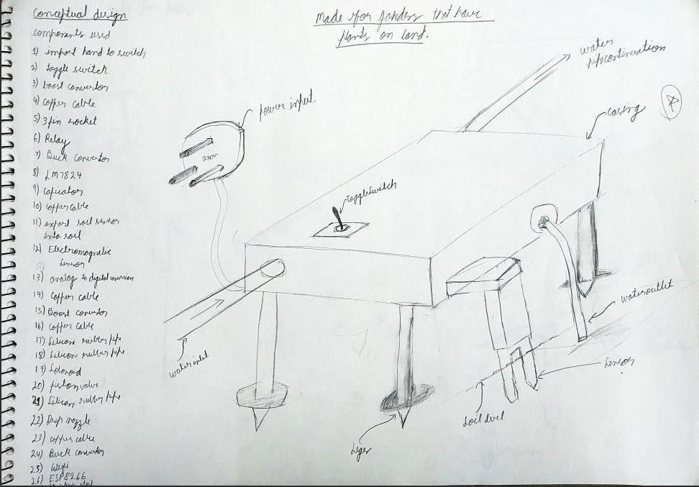

*Fig 4.d Conceptual design 1*

Conceptual design 2:

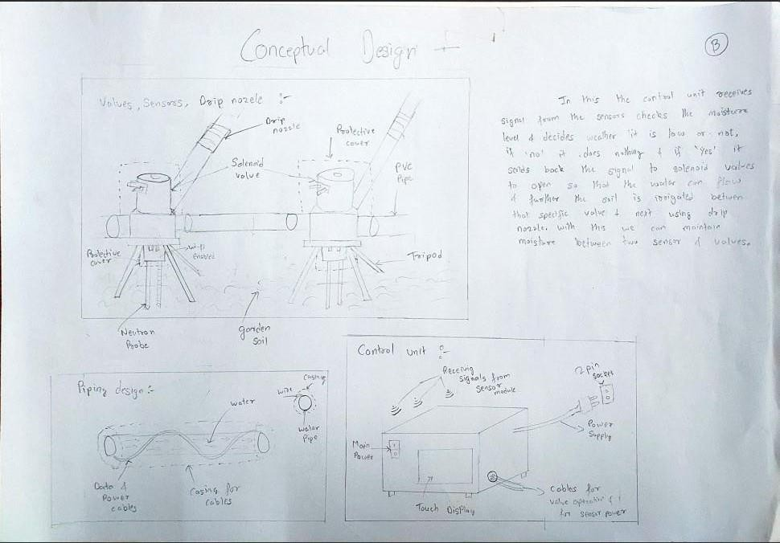

*Fig 4.e Conceptual design 2*

Conceptual design 3:

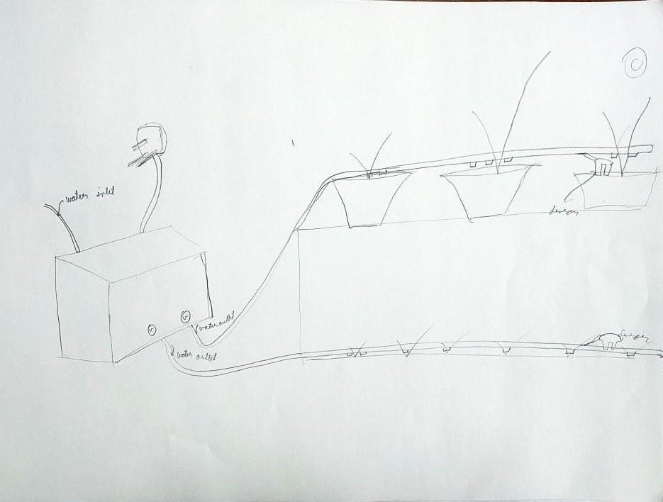

*Fig 4.f Conceptual design 3*

Conceptual design 4:

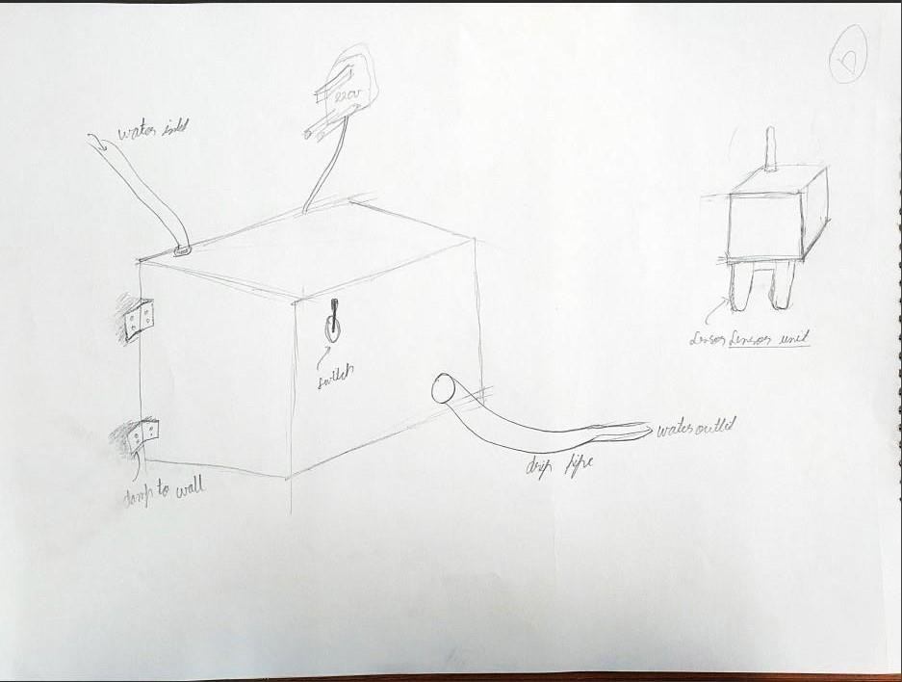

*Fig 4.g Conceptual design 4*

Conceptual design 5:

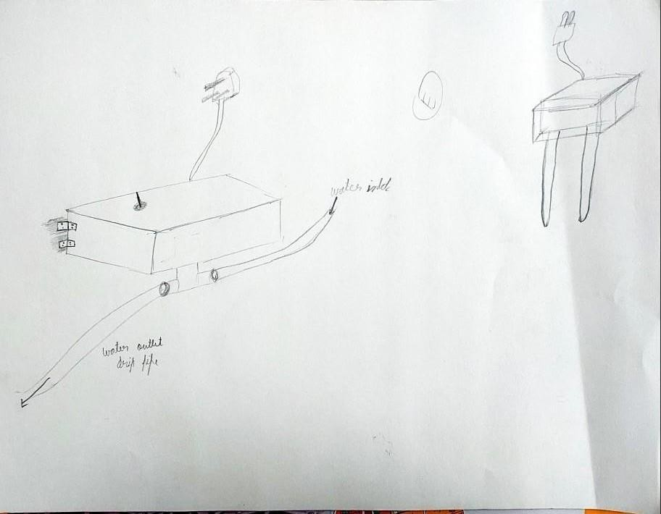

*Fig 4.h Conceptual design*

Conceptual design 6:

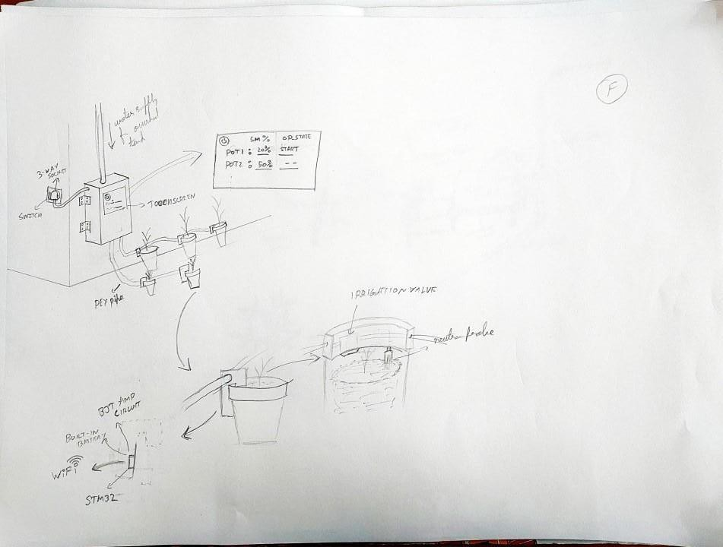

*Fig 4.i Conceptual design 6*

Conceptual design 7 :

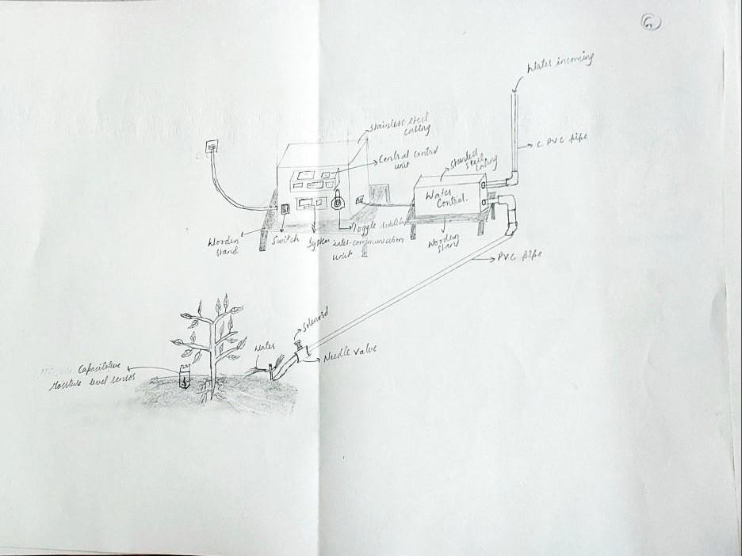

*Fig 4.j Conceptual design 7*

* + 1. Evaluation of alternate solutions

Evaluation of the concepts involves various comparisons either in an absolute or in a relative manner among several possible design concepts.

1. Absolute Comparison of Design Concepts

It consists of comparing the concepts to a series of absolute filters.

* 1. Evaluation based on judgment of feasibility of the design: This is the first screening and involves an assessment of the feasibility of the design concepts by the experts.
  2. Evaluation based on assessment of technology readiness:

This is the second screening and involves an assessment of the readiness of a product manufacturer to produce the designed product without additional research efforts.

* 1. Evaluation based on go-no-go screening of the customers’ requirements:

This step involves an evaluation whether the design has undertaken the customers’ requirements or feedbacks. Each customer requirement should be transformed in to a question and should be answerable as either yes (go) maybe(go) or no (no-go). This should help to eliminate any design concept that cannot address an important customer requirement.

1. Relative Comparison of Design Concepts It can be done in two ways;
2. Pugh’s evaluation matrix
   1. Numerical evaluation matrices
   2. The Priority Checkmark Method
   3. The Best-of-Class Method
3. The decision matrix

Concept Evaluation Method:

The concept evaluation is performed using the following steps: Step 1. Choose the comparison criteria:

* If all alternatives fulfill the demands on the same level, then the criteria should be listed in the specification table or the design criteria.
* Different weighing schemes could be used in the ordering of demands:
* a. Absolute factor, where each demand is evaluated individually on a scale from 0 to 10. Other demands will not interfere with the weigh factor used.
* b. Relative scale, where the sum of the demands is assigned a scale from 0 to 100. Each demand is assigned a weighing factor that corresponds to its importance relative to the

other demands. However, when the weighing factors are added, they should equal 100.

Step 2. Select the alternatives to be compared:

* From the morphological chart, different alternatives will be generated. Some of these alternatives will be dropped because they do not satisfy the customer demands or are not feasible.
* The rest of the alternatives are possible candidates. However, by using the initial

screening stages, a few alternatives will be left for the final stage. Not all feasible alternatives will be allowed to enter the final stage.

Step 3. Generate scores:

* The above points are common for either Pugh’s Evaluation Matrix or the Decision Matrix.

Concept Screening using Pugh’s Evaluation method Step 1 – Prepare the Selection Matrix.

* Enter concepts and criteria into the matrix.
* Select reference concept (industry standard, main competitor, current product). Its performance is rated using 0’s.

Step 2 – Rate the Concepts.

* Concepts that perform better than the reference are rated with +’s.
* Concepts that perform similarly compared to the reference are rated with 0’s.
* Concepts that perform worse than the reference are rated with –’s.

Step 3 – Rank the Concepts.

* Sum up “better than”, “same as”, and “worse than” and enter the sum for each category in the lower rows of the matrix.
* The net score is calculated by subtracting the number of “worse than” from the number of “better than”.

Step 4 – Combine and Improve Concepts.

* Is there a generally good concept which is degraded by a single bad feature?
* Are there two concepts which can be combined to preserve the “better than” qualities while cancelling the “worse

than” features?

Step 5 – Select One or More Concepts.

* After the team has gained sufficient understanding of each concept and its relative quality, a small number of concepts are chosen for further analysis and refinement (and

perhaps testing).

Step 6 – Reflect on the Results and Process.

* All team members should be comfortable with the outcome. Differences between team members may indicate missing criteria or rating errors.

Concept Screening:

*Table No. 4.d Concept screening*

|  |  |  |  |  |  |  |  |  |
| --- | --- | --- | --- | --- | --- | --- | --- | --- |
| Selection Criteria | | Concept Variants | | | | | | |
| A | B | C | D | E | G | Datum(F) |
| Cost (4) | | (+) | - | (+) | (+) | (+) | - | 0 |
| Quality (7) | | 0 | 0 | 0 | 0 | 0 | 0 | 0 |
| Material (5) | | 0 | (+) | (+) | 0 | 0 | 0 | 0 |
| Geometry (5) | | - | 0 | (+) | 0 | 0 | - | 0 |
| Transport (5) | | (+) | - | (+) | 0 | 0 | - | 0 |
| Ergonomics (6) | | - | 0 | 0 | 0 | - | - | 0 |
| Safety (10) | | - | (+) | 0 | (+) | (+) | (+) | 0 |
| Energy (7) | | (+) | - | (+) | 0 | (+) | 0 | 0 |
| Operation (7) | | 0 | 0 | 0 | 0 | 0 | 0 | 0 |
| Maintenance (5) | | - | 0 | 0 | (+) | (+) | - | 0 |
| Assembly (6) | | (+) | 0 | (+) | (+) | - | - | 0 |
| Ease of use (7) | | - | - | (+) | - | (+) | 0 | 0 |
| Time (9) | | 0 | 0 | - | - | 0 | 0 | 0 |
| Schedule (7) | | 0 | 0 | 0 | 0 | 0 | 0 | 0 |
| Simple understanding (6) | | (+) | 0 | (+) | 0 | (+) | 0 | 0 |
|  | Pluses | 5 | 2 | 8 | 4 | 5 | 1 |  |
|  | Same | 5 | 9 | 6 | 9 | 7 | 8 |  |
|  | Minus | -5 | -4 | -1 | -2 | -2 | -6 |  |
|  | NET | 0 | -2 | 7 | 2 | 3 | -5 |  |
|  | Rank | 4 | 5 | 1 | 3 | 2 | 6 |  |
|  | Continue? | Yes | No | Yes | Yes | Yes | No |  |

Concept Scoring:

Similar to concept screening criterias are weighted according to their importance.

Weighted Decision Matrix:

A decision matrix is used to evaluate the competing design concepts by ranking them with weighting factors and scoring the degree to which each design concept meets the criteria.

1. Identify the Criteria:

The more specific the criteria are, the better will be the results of the evaluation. While it is also desirable to have the criteria that are independent of one another, it is rarely possible.

1. Rank and Weigh the Criteria:

Some criteria are probably more important than the others. The relative ranking of the criteria will off course affect the evaluation. It is therefore preferable to find out a way of assigning weights to the criteria so that their relative importance (e.g., reliability may be more important than cost of the part) can be quantified. We can consider the following criteria and the respective weights within parenthesis.

1. Choose a Ranking Scale:

In order to evaluate each design concept option, we need to confirm which one is better (with respect to each criterion).

*Table No. 4.e Concept scoring*

|  |  |  |  |  |  |  |  |
| --- | --- | --- | --- | --- | --- | --- | --- |
|  | | Concepts | | | | | |
| Selection Criteria | Weight(Percentage) | A | | D | | CE | |
| Ranking | Weighted Score | Rankin g | Weighted Score | Rankin g | Weighted Score |
| Cost | 9 | 2 | 0.18 | 2 | 0.18 | 4 | 0.36 |
| Quality | 7 | 3 | 0.21 | 2 | 0.14 | 3 | 0.21 |
| Material | 7 | 3 | 0.21 | 3 | 0.21 | 3 | 0.21 |
| Geometry | 5 | 2 | 0.1 | 3 | 0.15 | 3 | 0.15 |
| Transport | 4 | 2 | 0.08 | 4 | 0.16 | 2 | 0.08 |
| Ergonomics | 5 | 2 | 0.1 | 5 | 0.25 | 4 | 0.2 |
| Safety | 8 | 1 | 0.08 | 4 | 0.32 | 5 | 0.4 |
| Energy | 9 | 2 | 0.18 | 4 | 0.36 | 4 | 0.36 |
| Operation | 7 | 3 | 0.21 | 3 | 0.21 | 4 | 0.28 |
| Maintenance | 8 | 2 | 0.16 | 3 | 0.24 | 3 | 0.24 |
| Assembly | 6 | 2 | 0.12 | 3 | 0.18 | 4 | 0.24 |
| Ease of use | 6 | 1 | 0.06 | 2 | 0.12 | 3 | 0.18 |
| Time | 7 | 3 | 0.21 | 3 | 0.21 | 3 | 0.21 |
| Schedule | 6 | 3 | 0.18 | 3 | 0.18 | 3 | 0.18 |
| Simple understanding | 6 | 2 | 0.12 | 2 | 0.12 | 2 | 0.12 |
|  | Total Sum | 2.2 | | 3.03 | | 3.42 | |
|  | Rank |  | |  | |  | |
|  | Continue? | NO | | Develop | | Develop | |

* + 1. Preliminary design – Final selected concept

After Concept Screening and Concept Scoring the conceptual design that is formed is:

Conceptual design CE:

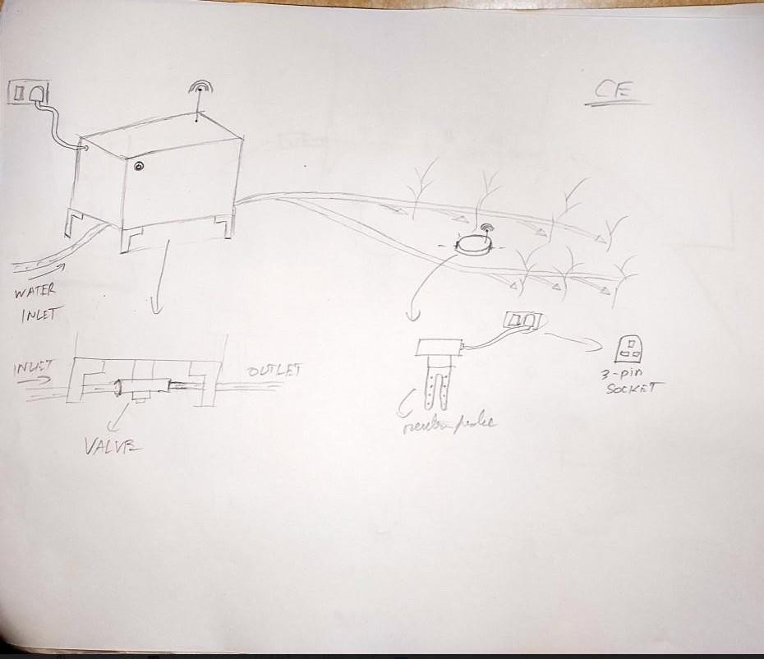

*Fig 4.k Conceptual design CE*

And the final Conceptual design:

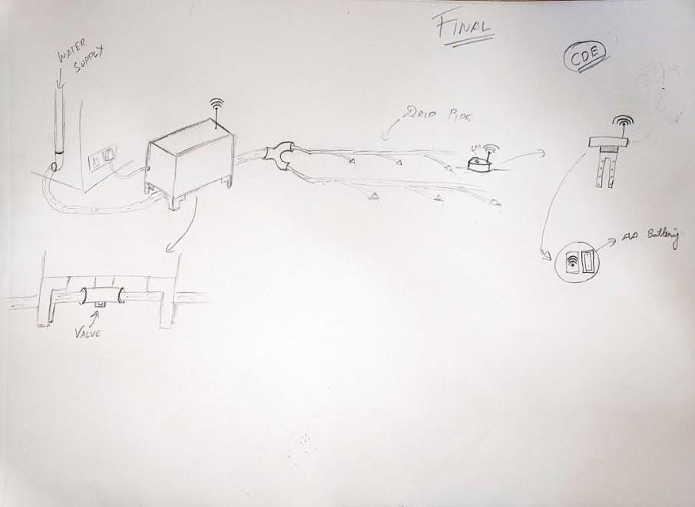

*Fig 4.l Final Conceptual Design*

### 5.1 Product Architecture: -

Product architecture is the organization (or chunking) of a product's functional elements. It's the ways these elements, or chunks, interact. It plays a significant role in how to design, make, sell, use, and repair a new product offering. Linking to system-level design and the principles of system engineering.

As per the Product architecture the solution is a consolidation of two Autonomous synchronously working system namely *Control unit* and *Sensor unit*.

The *Control unit* is responsible for the water flow management whereas the *Sensor unit* is responsible for the feedback mechanism by measuring the soil moisture level.

The synchronous interdependent action of the two systems allows to regulate the soil moisture level.

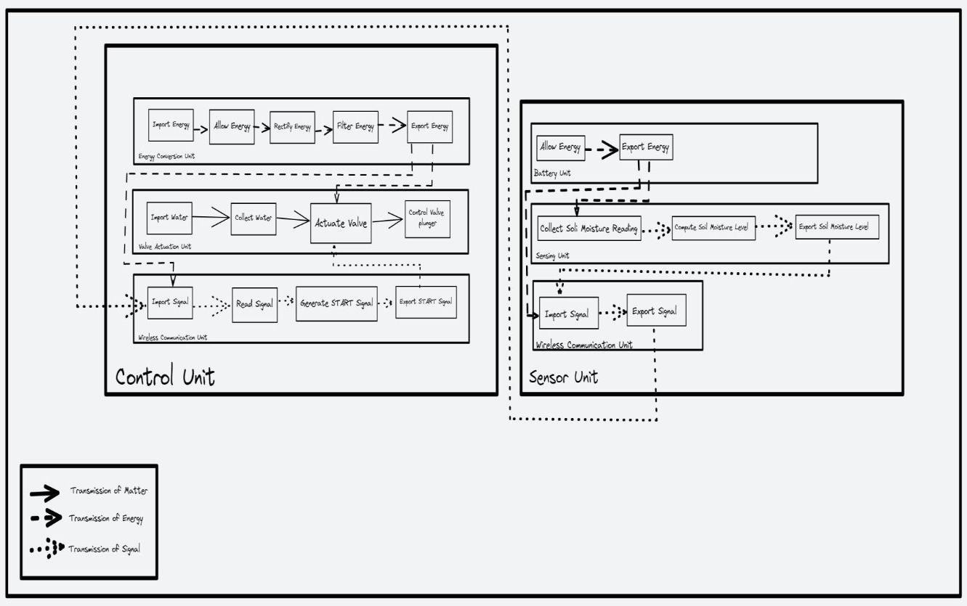

*Fig 5.1.a Schematic diagram*

Configuration design is a kind of design where a fixed set of predefined components that can be interfaced in predefined ways is given, and an assembly of components selected from this fixed set is sought that satisfies a set of requirements and obeys a set of constraint.

The components placed in the *Control unit: -*

* Power supply: Adapter 12v and 5A
* Power flow regulator: Toggle switch
* Voltage modifier: Step down converter
* Wireless communication: Wi-Fi module- ESP 32
* Valve actuator: Solenoid 12v and 5A
* Valve flange: Pin plunger

The components placed in the *Sensor unit*: -

* Power supply: Battery pack and AA Batteries
* Power flow regulator: Toggle switch
* Wireless communication: Wi-Fi module-ESP 32
* Moisture sensor: Capacitive sensor

### 5.3 Parametric design

Control unit: -

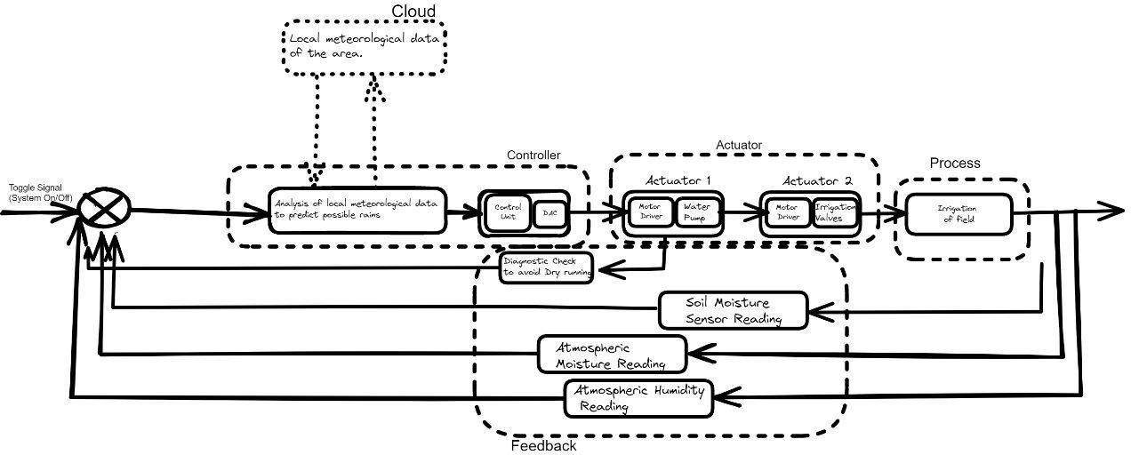

*Fig 5.3.a Parametric functioning of Control unit*

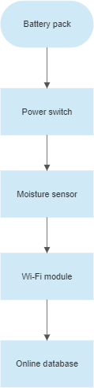Sensor unit: -

*Fig 5.3.b Parametric functioning of Sensor unit*

# Detailed design

## Selection of material

Selected material: Acrylic (Polymethyl Methacrylate or PMMA) or Plexiglass

Technical specifications: -

Table No.6a : Technical specification

|  |  |
| --- | --- |
| Relative Density | 1.19 g/cm3 |
| Rockwell Hardness | M 102 |
| Water Absorption | -.2% |
| Flammability | Class 3, (BS 476 pt. 7) UL94 HB |
| Tensile Strength | 75 MPa |
| Flexural Strength | 115 MPa |
| Minimum Service Temperature | -40⁰C |
| Maximum Service Temperature | 80⁰C |
| Softening Point | > 110⁰C |
| Linear Expansion | 7.7×10-5 |
| Light Transmission | > 92% |
| Refractive Index | 1.49 |



*Fig 6.a Acrylic sheet*

Advantages of Acrylic: -

* + - Excellent optical clarity & transparency-Easier to diagnose errors.
    - Highly Water Resistant.
    - Highly resistant to variations in temperature.
    - Up to 17 times the impact resistance of ordinary glass.
    - Half the weight of glass and ideal for precision machining.
    - Highly resistant to many different chemical reactions.
    - Cost efficient when compared to other alternatives.

## Elaborate detail drawings and parts list

1. Toggle switch

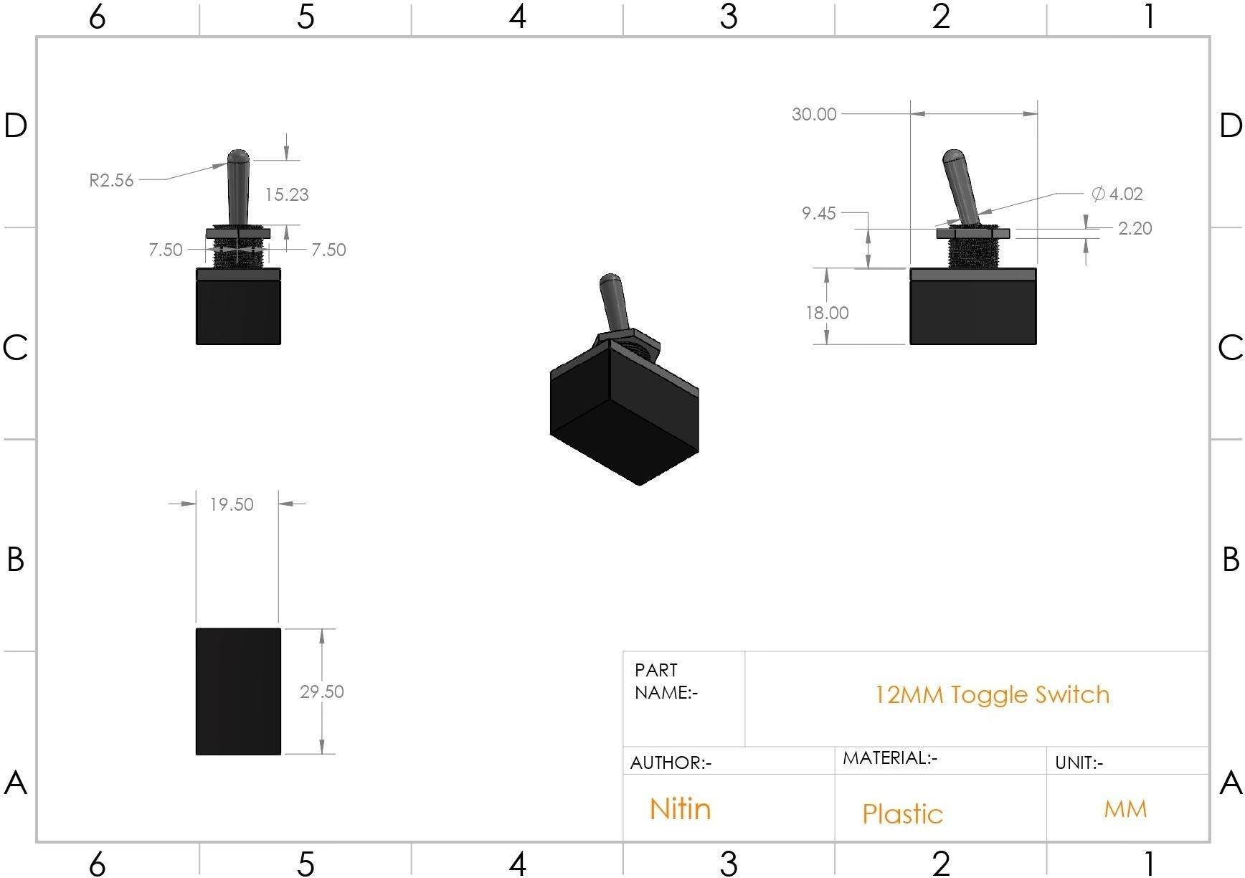

*Fig 6.2.a Toggle switch*

1. Relay

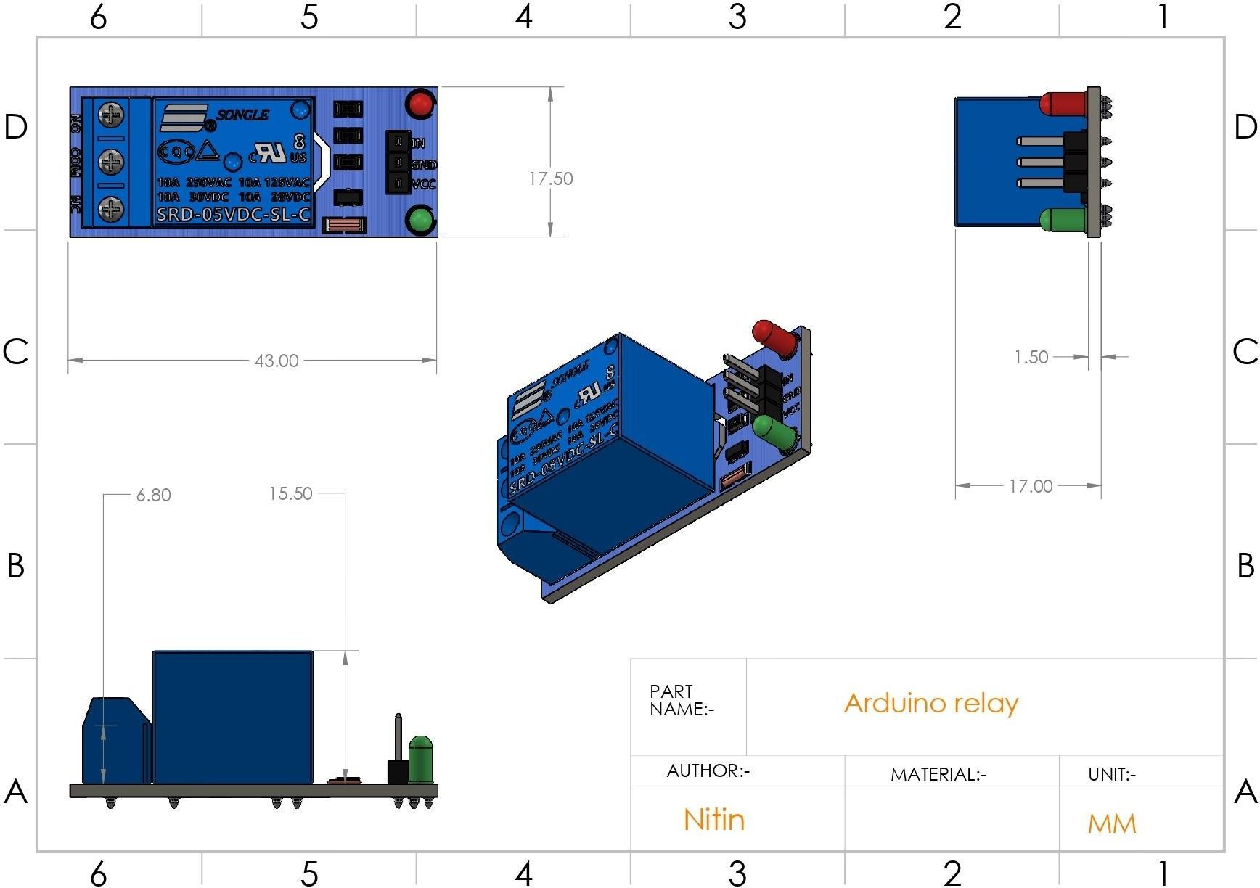

*Fig 6.2.b Relay*

1. Battery case

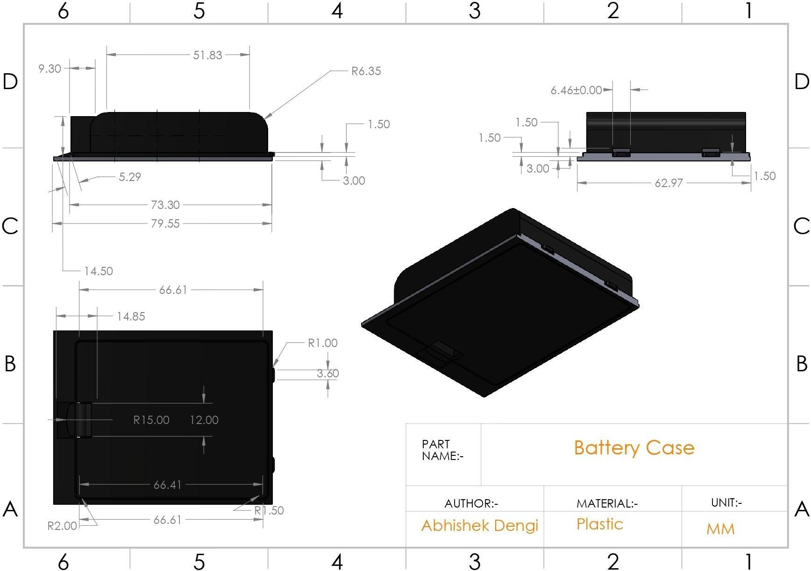

*Fig 6.2.c Battery case*

1. Control unit box

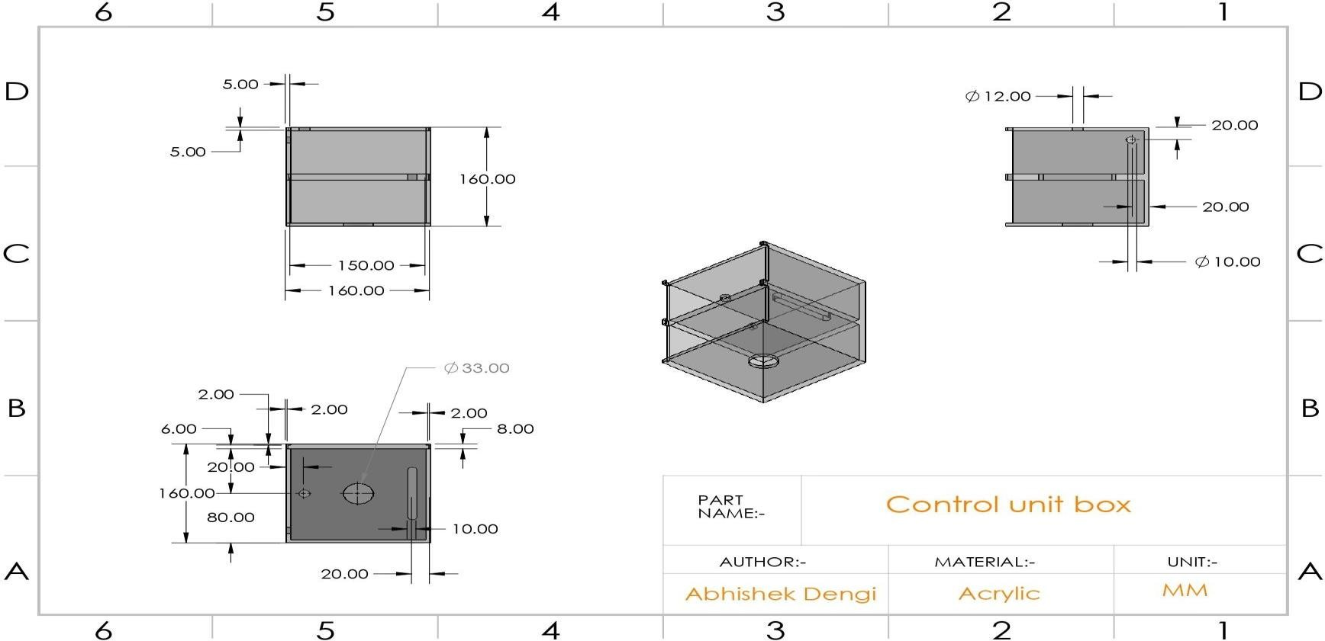

*Fig 6.2.d Control unit box*

1. Control unit slider

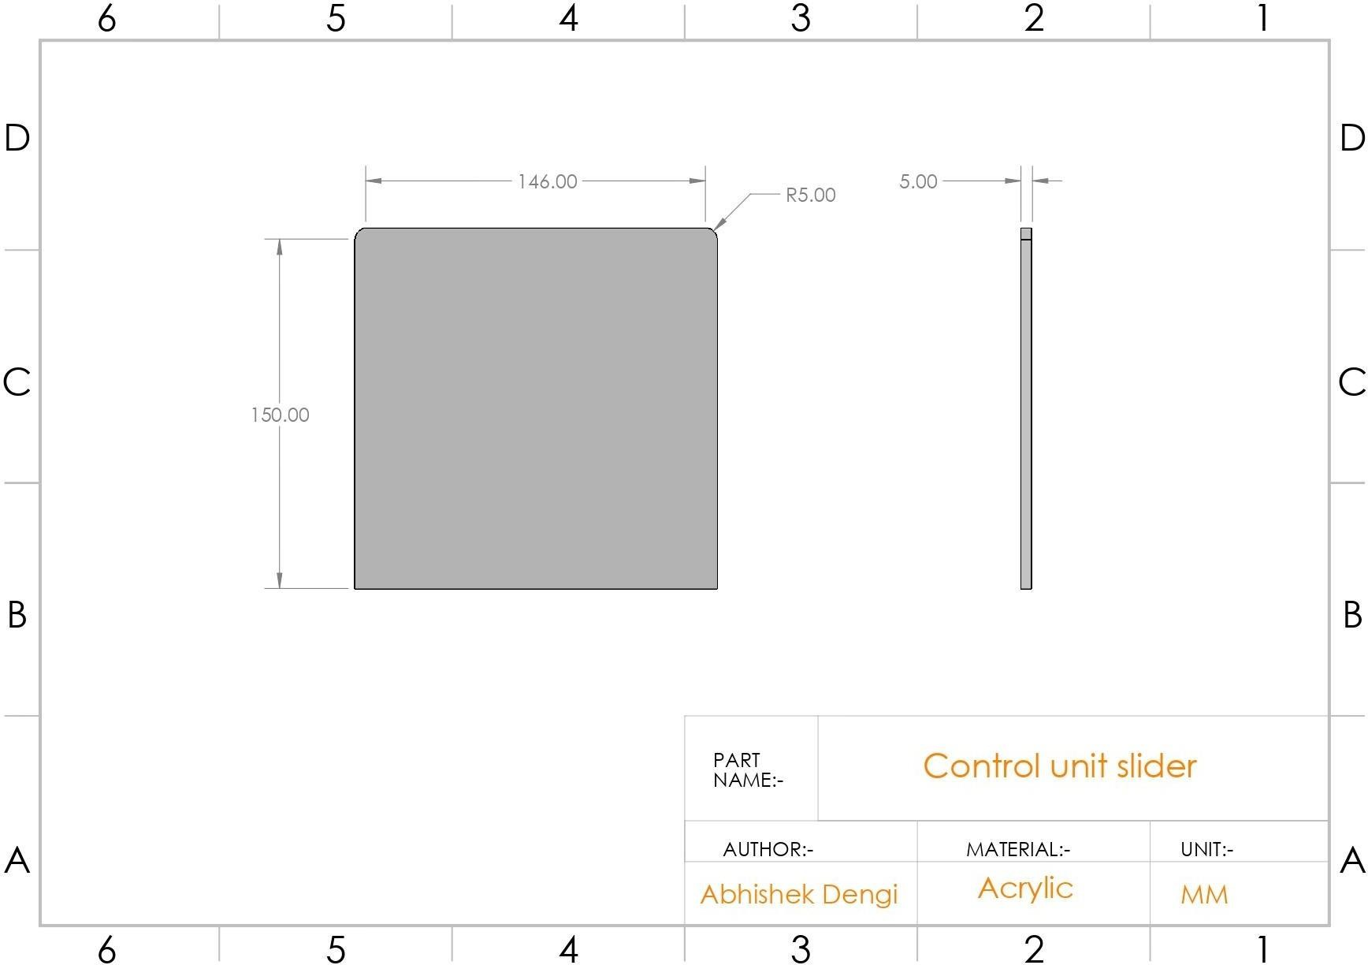

*Fig 6.2.e Control unit slider*

1. DC-DC Step down

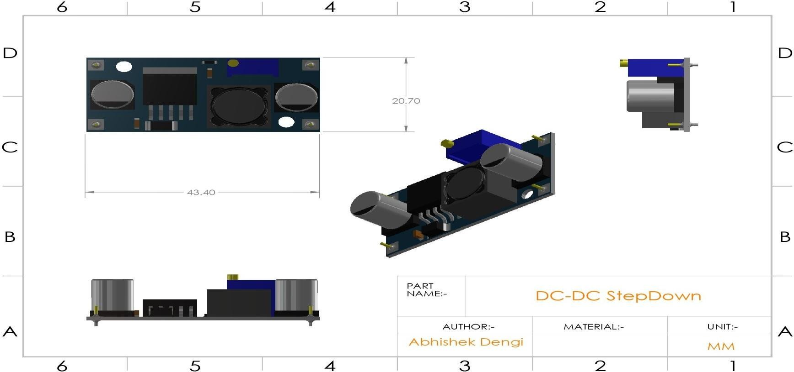

*Fig 6.2.f DC-DC Stepdown*

1. ESP 8266 NodeMCU

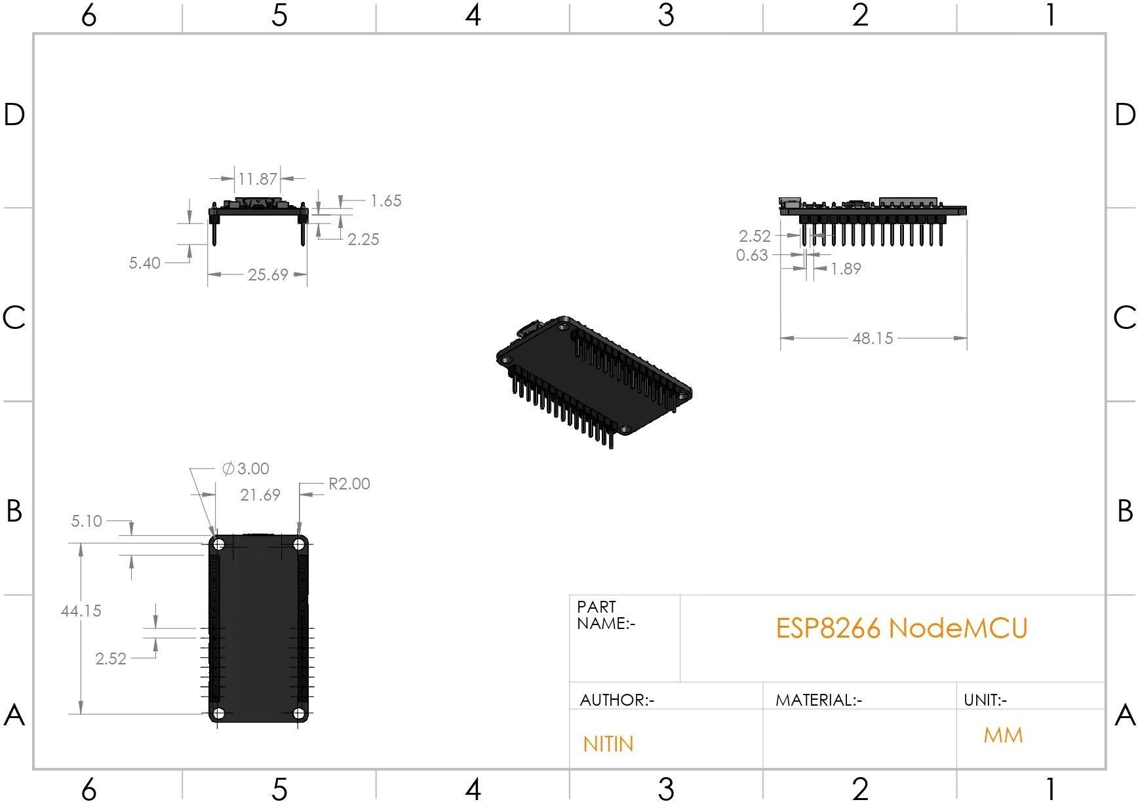

*Fig 6.2.g ESP8266 NodeMCU*

1. Soil moisture sensor

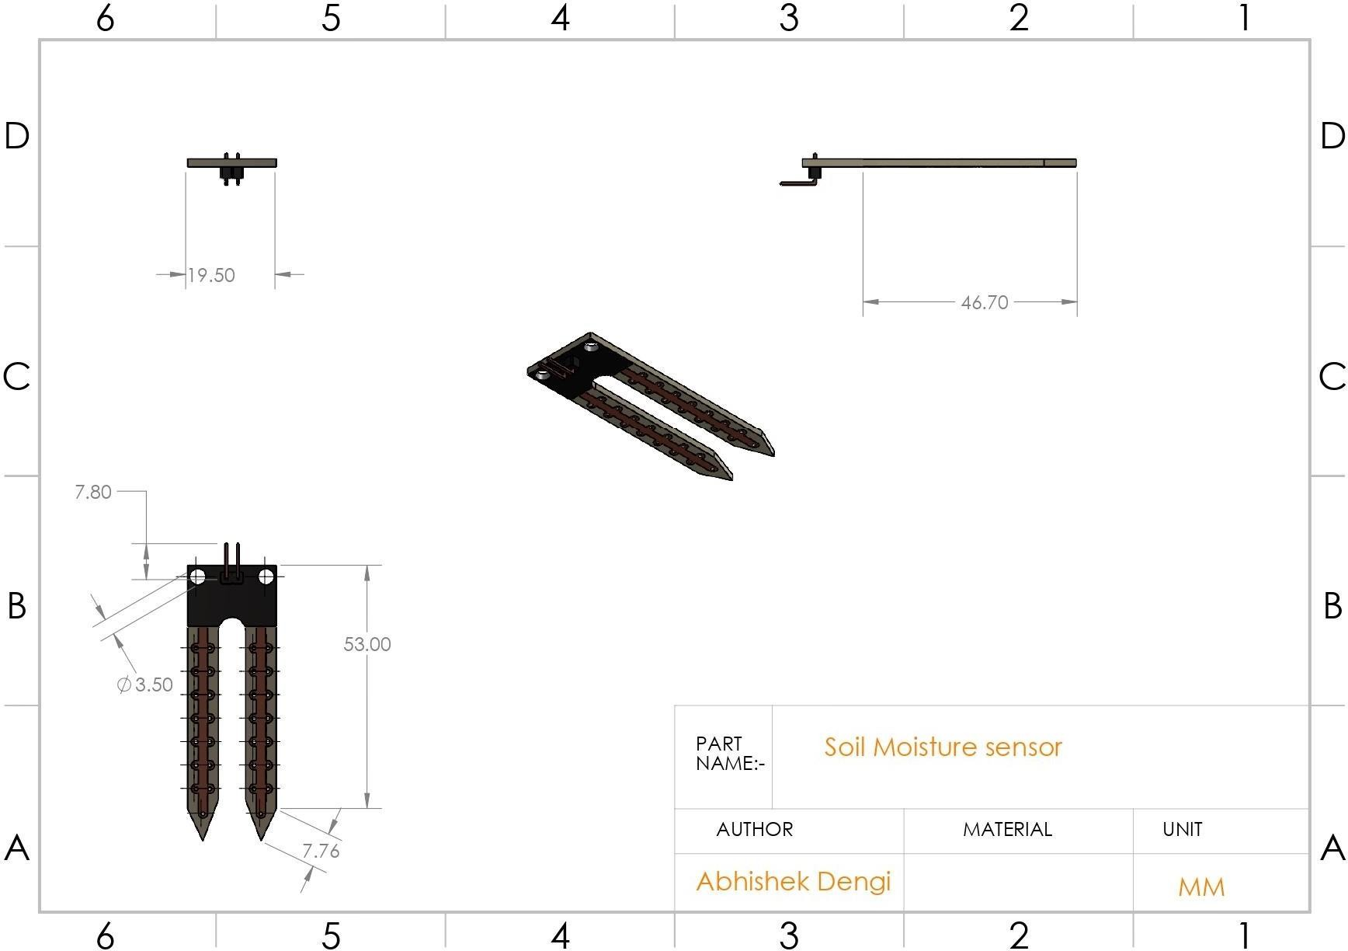

*Fig 6.2.h Soil moisture sensor*

1. Sensor unit box

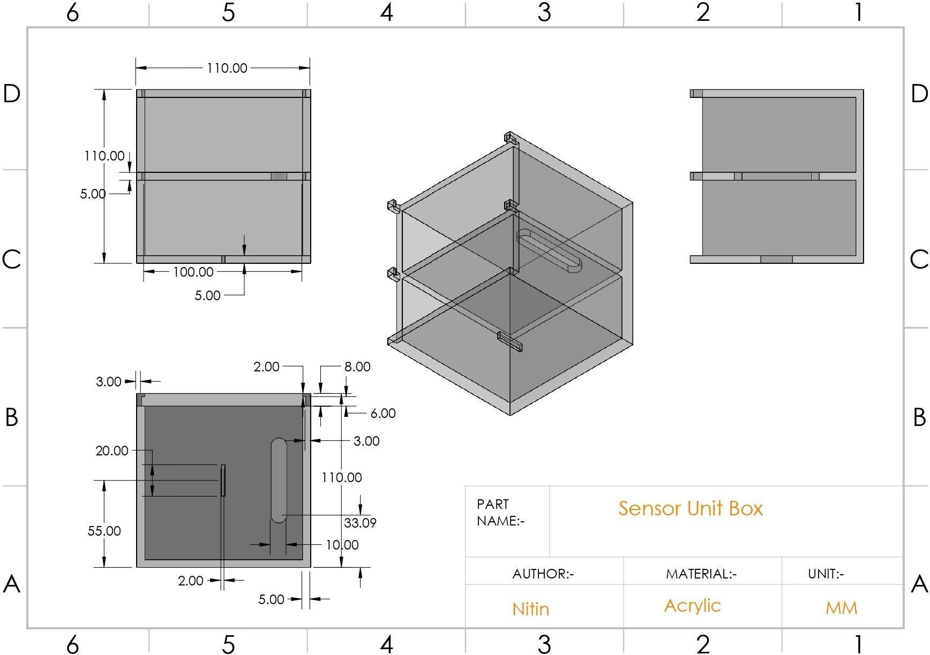

*Fig 6.2.i Sensor unit box*

1. Sensor unit slider

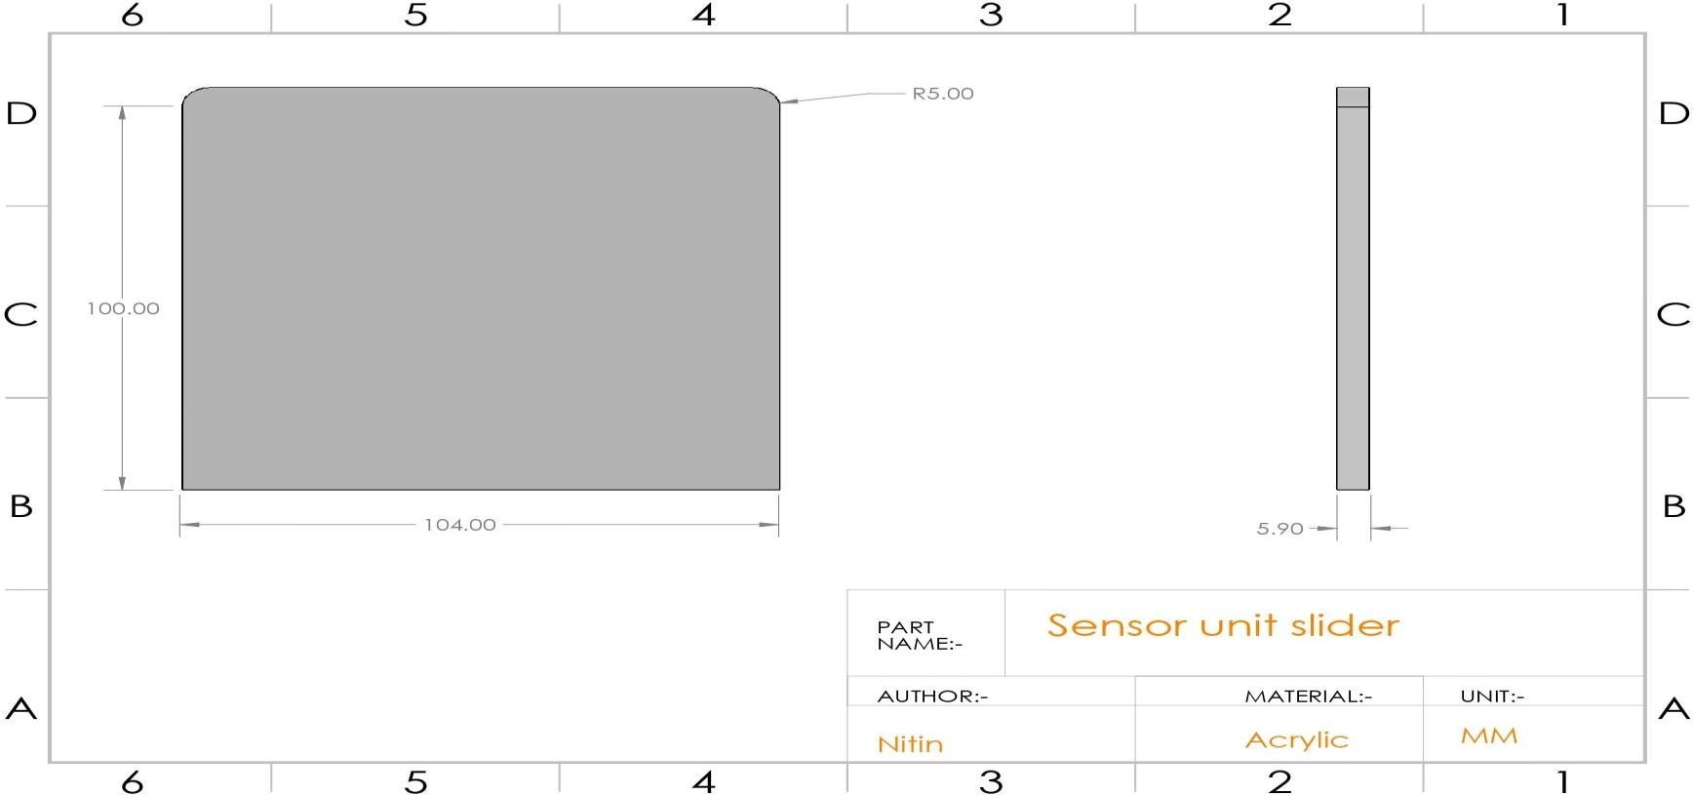

*Fig 6.2.j Sensor unit slider*

1. Solenoid valve

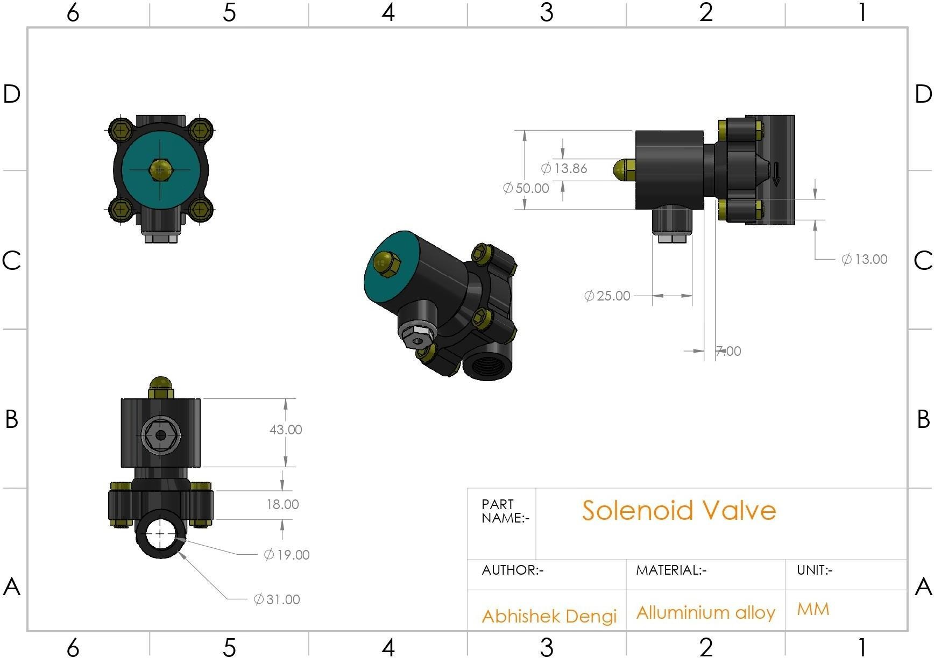

*Fig 6.2.k Solenoid valve*

* 1. **Bill of materials**

*Table 6.3.a Component list*

|  |  |  |
| --- | --- | --- |
| **ITEM No.** | **Part Name** | **QTY.** |
| 1 | Control unit box | 1 |
| 2 | Control unit slider | 1 |
| 3 | Toggle switch | 1 |
| 4 | Solenoid valve | 1 |
| 5 | 5 V single channel relay | 1 |
| 6 | Node MCU Board | 2 |
| 7 | DC-DC step down | 1 |
| 8 | Pipe | 1 |
| 9 | Sensor unit box | 1 |
| 10 | Battery case | 1 |
| 11 | Soil-Moisture sensor | 1 |
| 12 | Sensor unit slider | 1 |
| 13 | Jumper wire | 1 |
| 14 | 12 V Adapter | 1 |
| 15 | AA Battery | 4 |
| 16 | Breadboard | 1 |

The total number of components used are 20

## Costing

*Table 6.4a Cost of components*

|  |  |  |  |
| --- | --- | --- | --- |
| **ITEM No.** | **Part Name** | **QTY.** | **Price in Rs.** |
| 1 | Control unit box | 1 | 300 |
| 2 | Control unit slider | 1 | 90 |
| 3 | Toggle switch | 1 | 10 |
| 4 | Solenoid valve | 1 | 450 |
| 5 | 5 V single channel relay | 1 | 45 |
| 6 | Node MCU Board | 2 | 392 |
| 7 | DC-DC step down | 1 | 72 |
| 8 | Pipe | 1 | 270 |
| 9 | Sensor unit box | 1 | 230 |
| 10 | Battery case | 1 | 30 |
| 11 | Soil-Moisture sensor | 1 | 50 |
| 12 | Sensor unit slider | 1 | 77 |
| 13 | Jumper wire | 1 | 50 |
| 14 | 12 V Adapter | 1 | 150 |
| 15 | AA Battery | 4 | 60 |
| 16 | Breadboard | 1 | 42 |

The total cost of the system is Rs. 2318

## Process sheets

The selected material majorly being acrylic is cut according to design by the laser cutting and is later assembled using Cyanoacrylate

## Documentation

* The following system involves watering of plants in a garden or a potted plant
* The system is composed of you units *a. Control unit* and *b. Sensor unit*
* The system works independently of each other; the units communicate wireless with the help of *Wi-Fi module*.
* The system is connected to the power supply with the help of an adapter.
* The input rectified power supply is of 12v and 2A.
* The system is called as *A.D.I.S* which is the abbreviation of *Automatic Domestic Irrigation System.*
* The water supply is obtained from an overhead tank.
* The operating requirement of the Solenoid valve is 12V and 2A of power supply.
* The system operates on the real time feedback system based on the Senor value
* The watering is actuated by the Solenoid once the Soil moisture is below the threshold level and stops when the valve is equal to or above the threshold level.
* The control unit shouldn’t be exposed to water/moisture.

# Working Model or Prototype – Include photographs of parts and Assemblies

* 1. Irrigation System

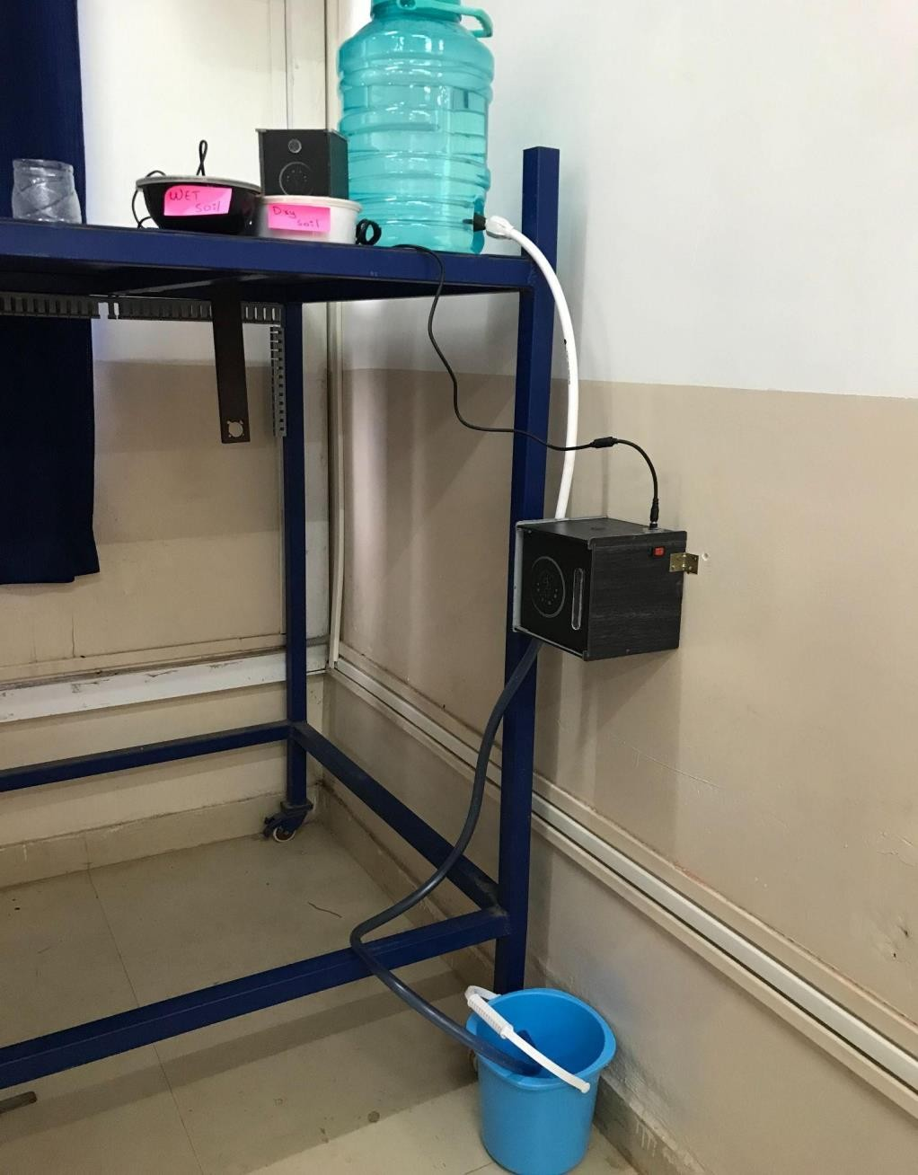

Fig 7.a *Irrigation system*

* 1. Control Unit

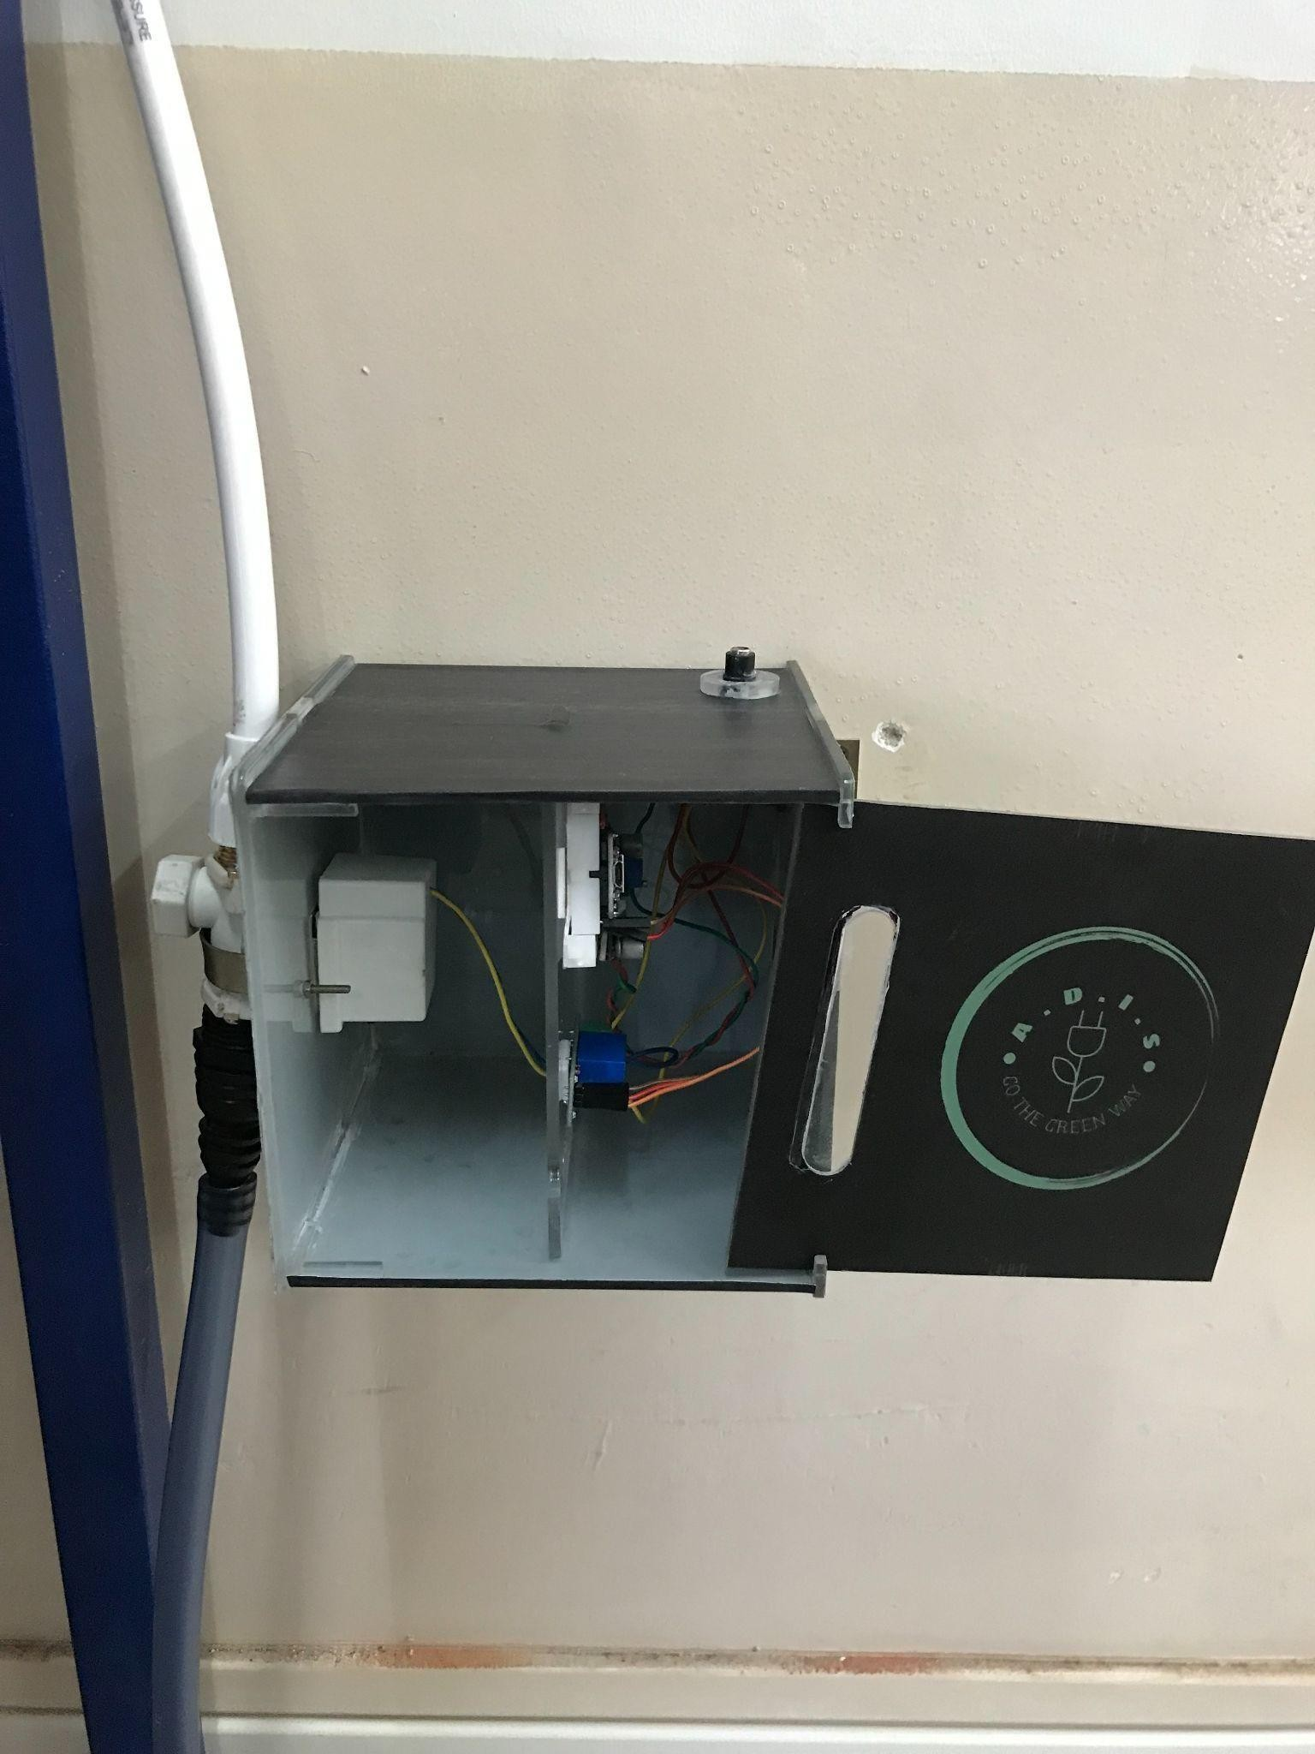

*Fig 7.b Control unit*

* 1. Sensor unit

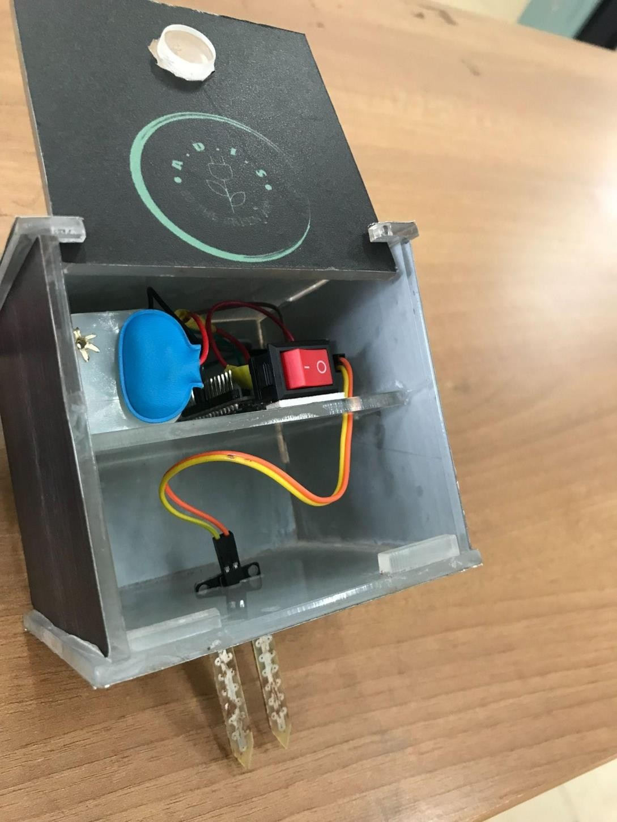

*Fig 7.c Sensor unit*

* 1. Dc–Dc step down

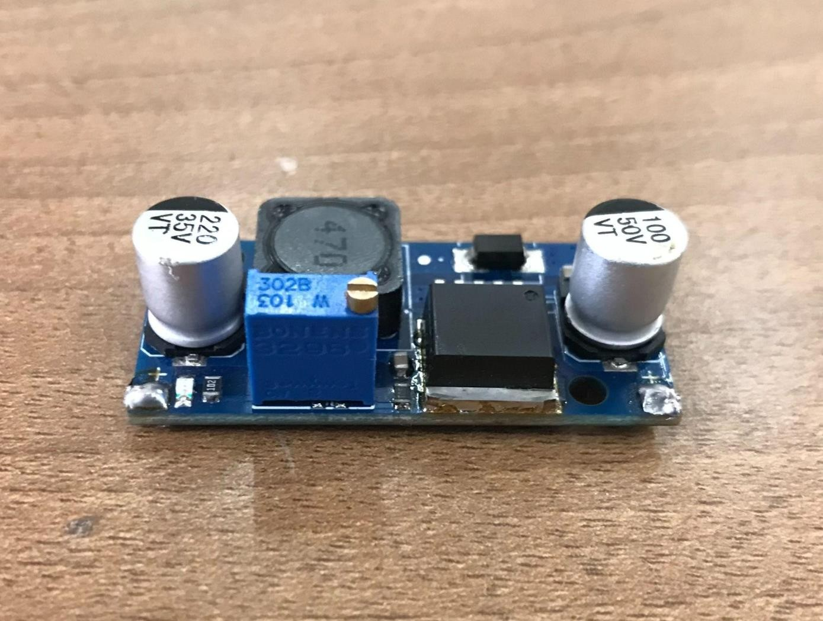

*Fig 7.d DC-DC step down*

* 1. Soil Moisture Sensor

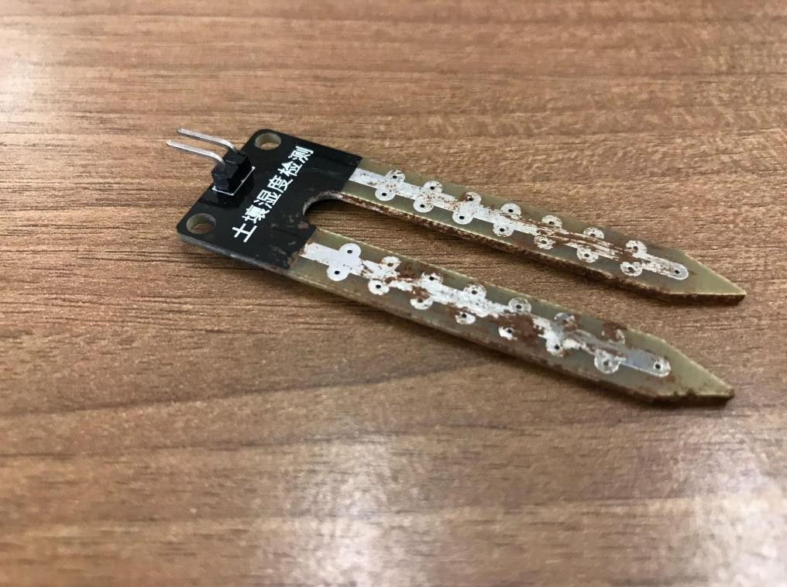

*Fig 7.e Soil moisture sensor*

* 1. AA Battery

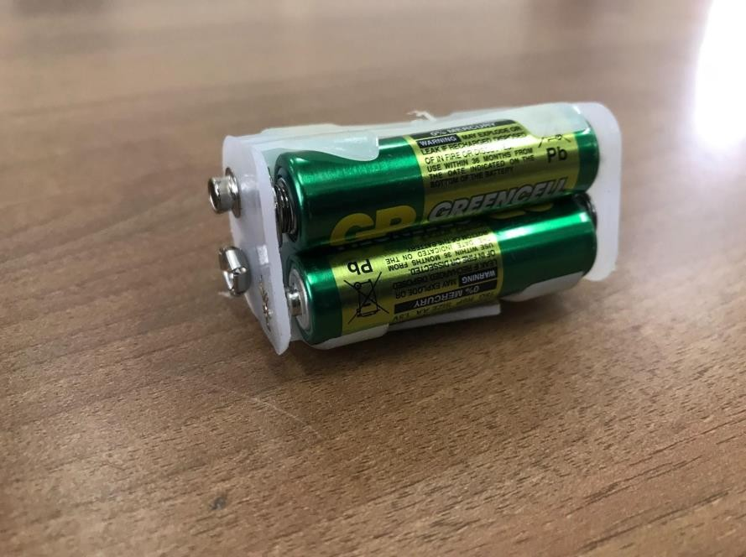

*Fig 7.f AA Battery*

* 1. Switch

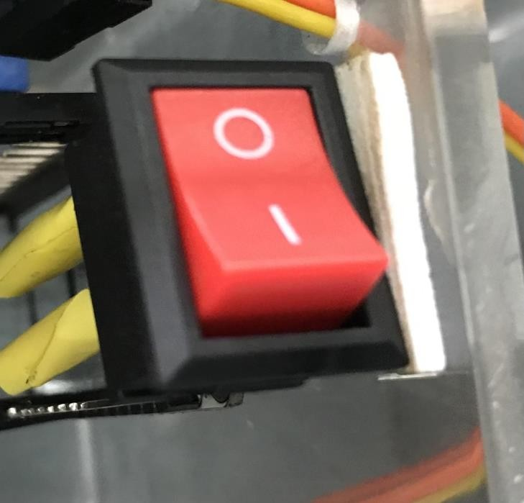

*Fig 7.g Toggle switch*

* 1. Single channel Relay

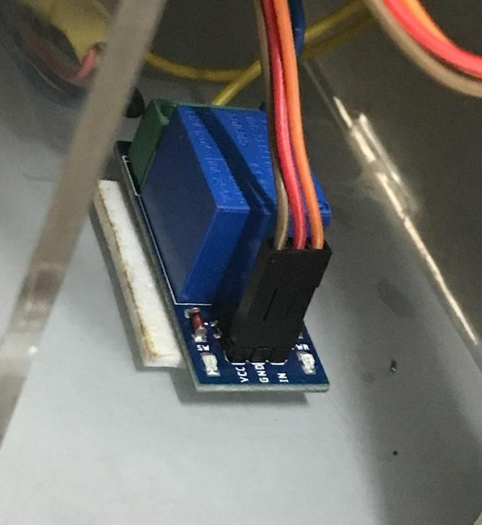

*Fig 7.h Single channel relay*

* 1. NodeMCU

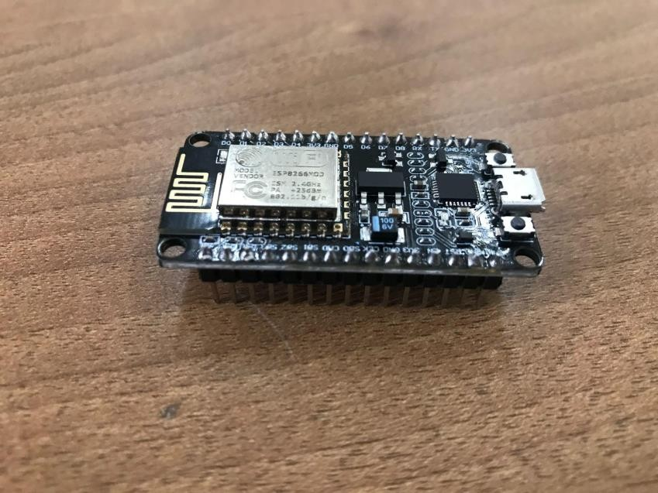

*Fig 7.i NodeMCU*

* 1. Solenoid valve

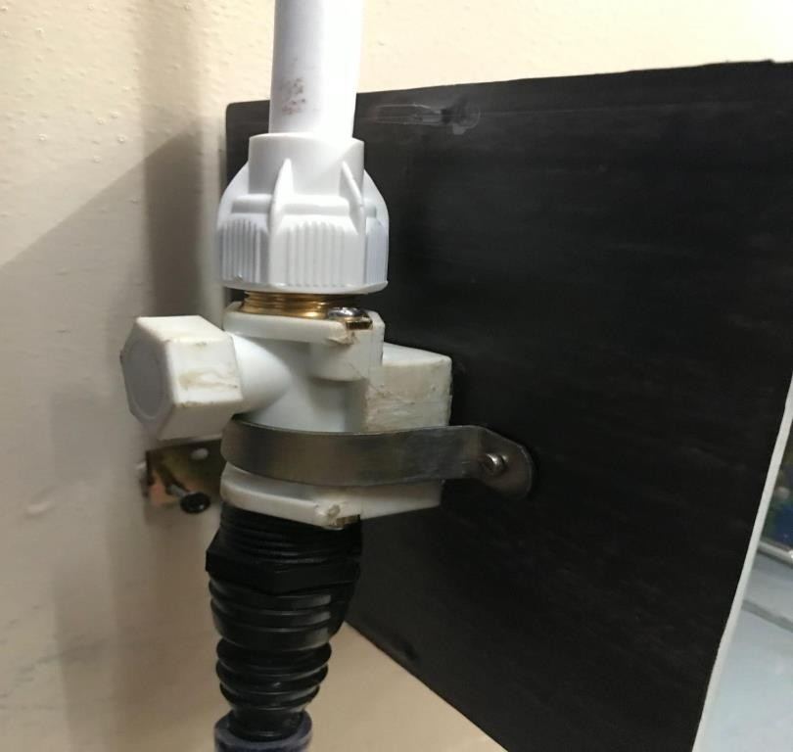

*Fig 7.j Solenoid valve*

# Testing and Evaluation

* 1. Working of Irrigation System

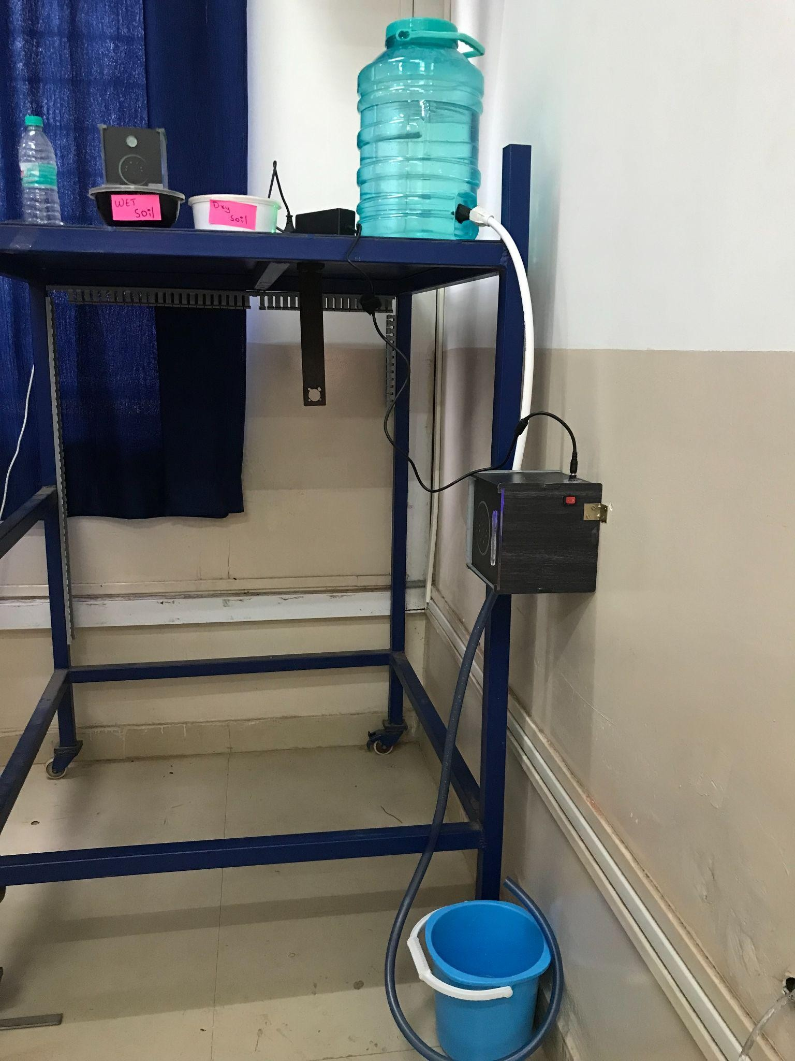

*Fig 8.a Working of Irrigation system*

* 1. Checking of Soil Moisture Level in Wet soil

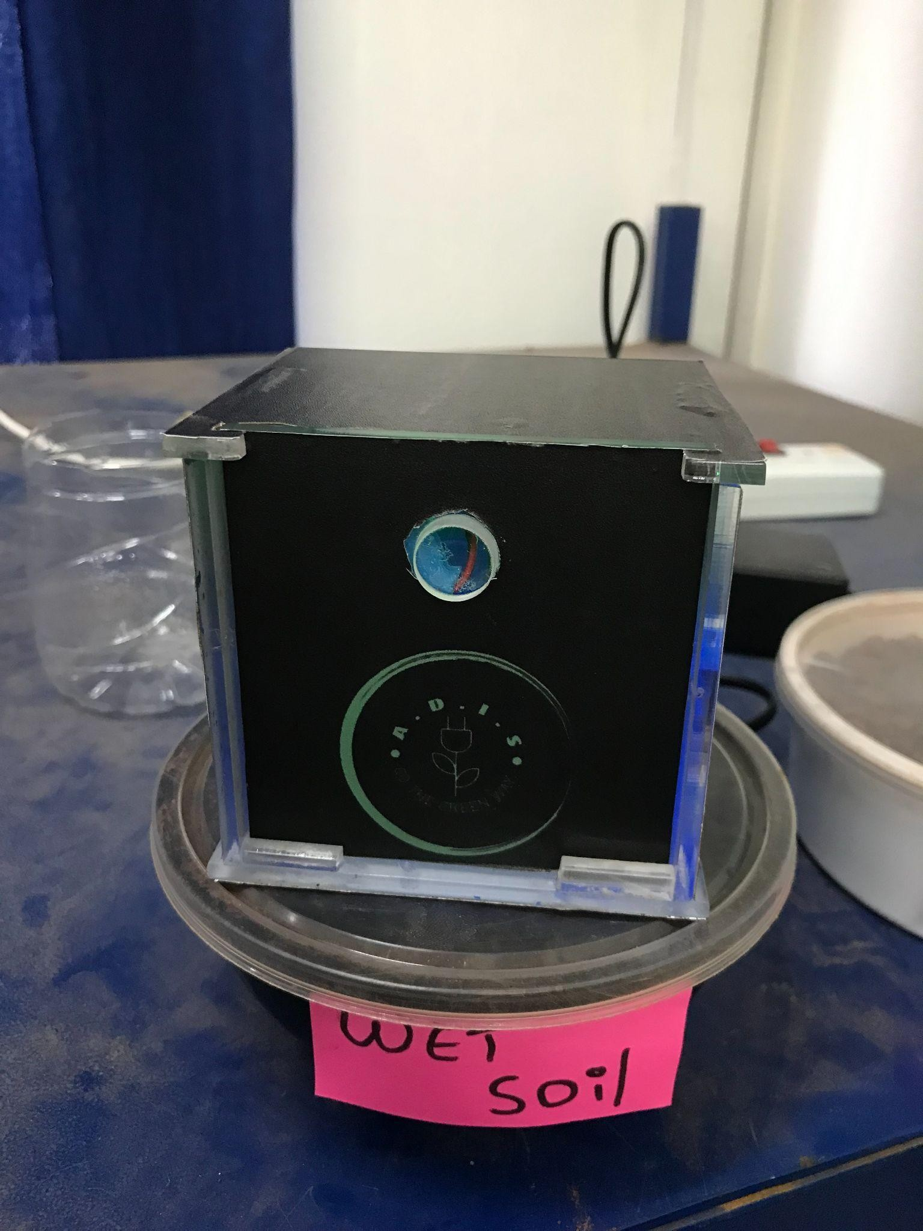

*Fig 8.b Soil Moisture Sensor in Wet Soil*

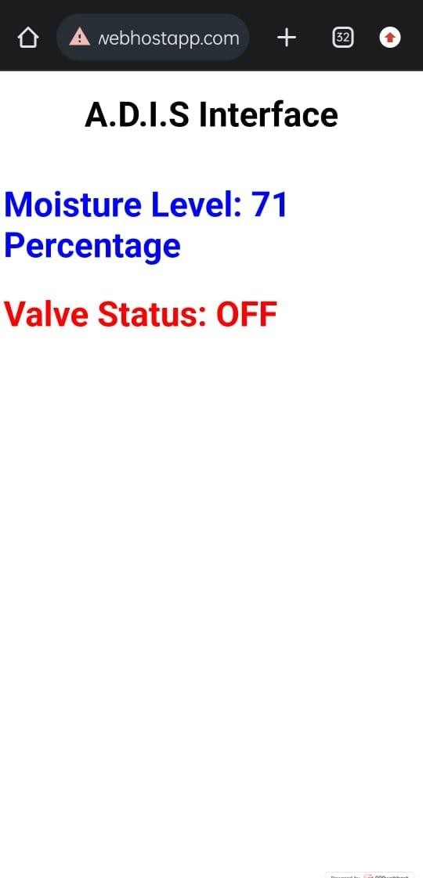

*Fig 8.c Soil Moisture Level in Wet soil*

* 1. Checking of Soil Moisture Level in Dry soil

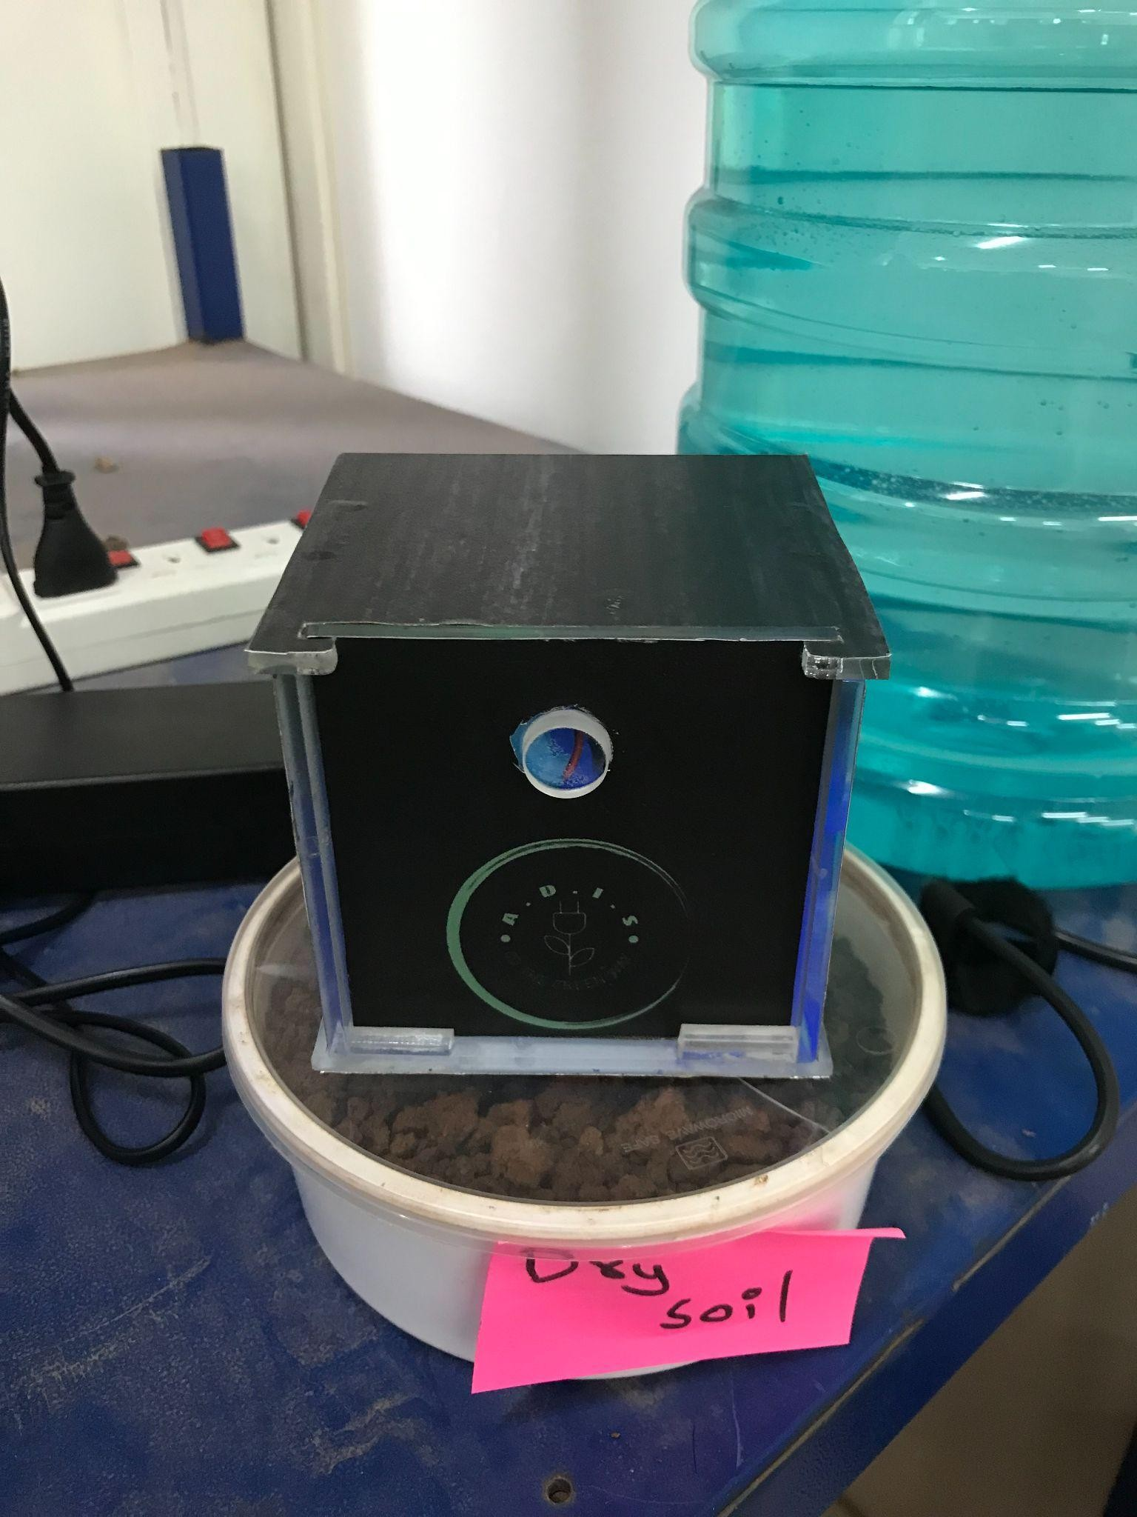

*Fig 8.d Soil Moisture Sensor in Dry Soil*

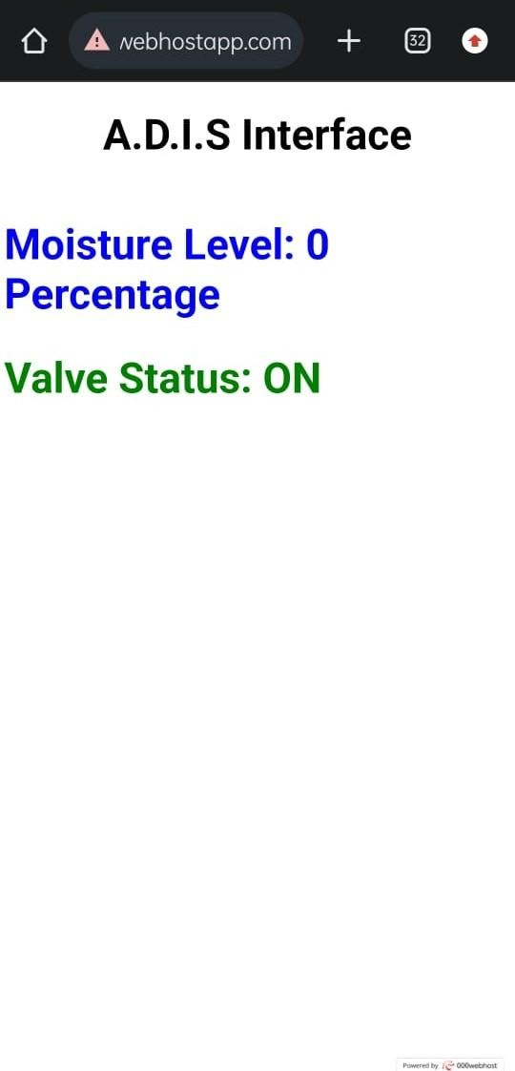

*Fig 8.e Soil Moisture Level in Dry soil*

* 1. Watering after the feedback

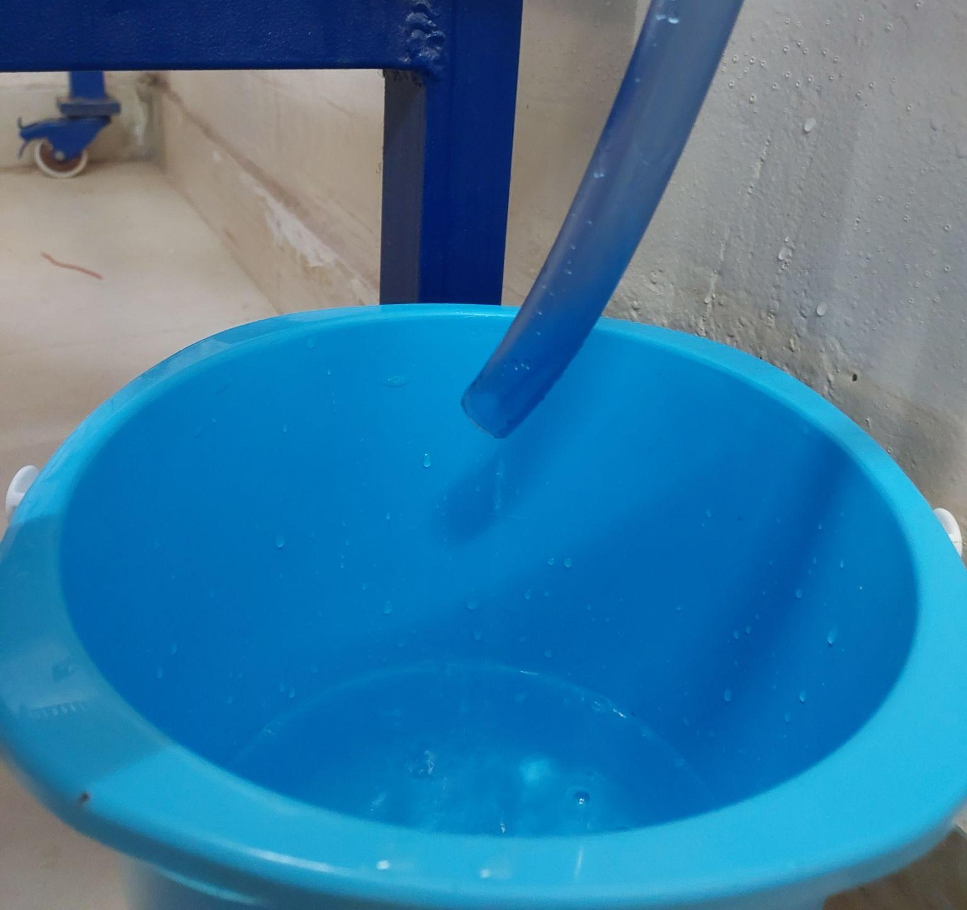

*Fig 8.f Watering*

* 1. Flow rate calculation

The flow rate is 115 ml/min

* 1. Sustainability

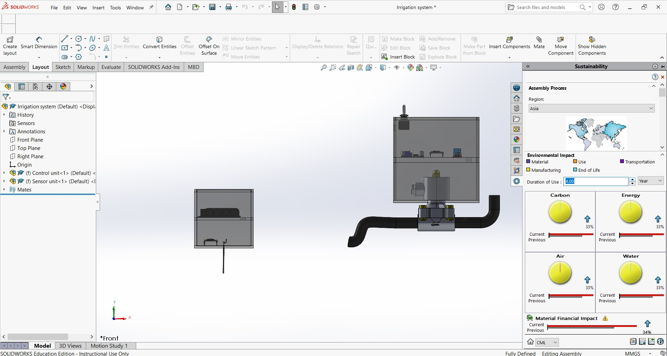

*Fig 8.g Sustainability*

*Team 01 Report*

# Conclusion (what worked and what did not work, improvements)

The soil moisture sensor detects the soil moisture level and sends the reading to

In conclusion, the domestic irrigation system project was a success. The installation of the system has improved the efficiency of watering the garden and has reduced water usage. The system would consist of a network of sprinklers or drip lines, controlled by a central irrigation controller, to efficiently distribute water to plants and lawns. The sensor-based irrigation system has also saved time and effort in maintaining the garden. Not only would it save water and reduce water bills, but it would also help to maintain a healthy and beautiful landscape. Overall, the domestic irrigation system project would improve the sustainability and aesthetic of the community.

### User interface of the working prototype:

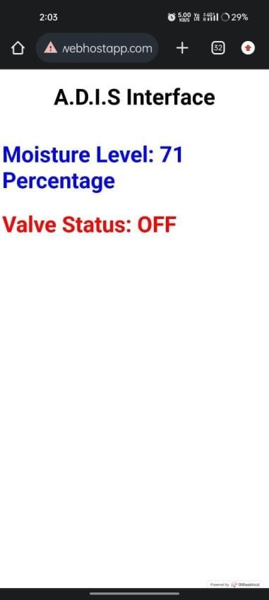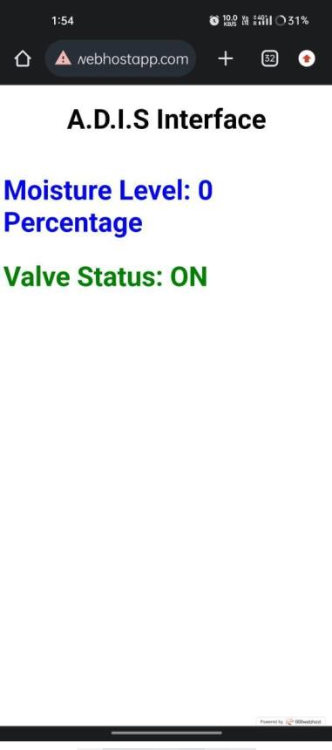

*Fig 9.a valve OFF*

# Appendix

IEEE Code of Ethics

We, the members of the IEEE, in recognition of the importance of our technologies in affecting the quality of life throughout the world, and in accepting a personal obligation to our profession, its members and the communities we serve, do hereby commit ourselves to the highest ethical and professional conduct and agree:

1. To uphold the highest standards of integrity, responsible behaviour, and ethical conduct in professional activities.
   1. to hold paramount the safety, health, and welfare of the public, to strive to comply with ethical design and sustainable development practices, to protect the privacy of others, and to disclose promptly factors that might endanger the public or the environment;
   2. to improve the understanding by individuals and society of the capabilities and societal implications of conventional and emerging technologies, including intelligent systems;
   3. to avoid real or perceived conflicts of interest whenever possible, and to disclose them to affected parties when they do exist;
   4. to avoid unlawful conduct in professional activities, and to reject bribery in all its forms;
   5. to seek, accept, and offer honest criticism of technical work, to acknowledge and correct errors, to be honest and realistic in stating claims or estimates based on available data, and to credit properly the contributions of others;
   6. to maintain and improve our technical competence and to undertake technological tasks for others only if qualified by training or experience, or after full disclosure of pertinent limitations;
2. To treat all persons fairly and with respect, to not engage in harassment or discrimination, and to avoid injuring others.
3. to treat all persons fairly and with respect, and to not engage in discrimination based on characteristics such as race, religion, gender, disability, age, national origin, sexual orientation, gender identity, or gender expression;
4. to not engage in harassment of any kind, including sexual harassment or bullying behaviour;
5. to avoid injuring others, their property, reputation, or employment by false or malicious actions, rumors or any other verbal or physical abuses;
6. To strive to ensure this code is upheld by colleagues and co-workers.
7. to support colleagues and co-workers in following this code of ethics, to strive to ensure the code is upheld, and to not retaliate against individuals reporting a violation.

### Code for Control Unit:

#include <ESP8266WiFi.h> #include <ESP8266HTTPClient.h> #include <WiFiClient.h> WiFiClient wifiClient;

#define ON_Board_LED 2 const int Valve_pin = 13;

const char* ssid = "G"; // --> wifi name

const char* password = "12345678"; //--> wifi password

const char *host = "https://domestic-irrigation.000webhostapp.com:80/";

String inString = ""; void setup()

{

Serial.begin(115200); delay(500); WiFi.mode(WIFI_STA); WiFi.begin(ssid, password); Serial.println("");

pinMode(ON_Board_LED, OUTPUT); digitalWrite(ON_Board_LED, HIGH); pinMode(Valve_pin, OUTPUT); pinMode(D0, OUTPUT); digitalWrite(D0, LOW);

Serial.print("Connecting");

while (WiFi.status() != WL_CONNECTED) { Serial.print("."); digitalWrite(ON_Board_LED, LOW); delay(250);

digitalWrite(ON_Board_LED, HIGH); delay(250);

}

digitalWrite(ON_Board_LED, HIGH); Serial.println(""); Serial.print("Successfully connected to : "); Serial.println(ssid);

Serial.print("IP address: "); Serial.println(WiFi.localIP()); Serial.println();

}

void loop() { HTTPClient http;

String GetAddress, LinkGet, getData, LEDStatResultSend; int wid = 0;

GetAddress = "GetData.php"; LinkGet = host + GetAddress; getData = "ID=" + String(wid);

Serial.println("----------------Connect to Server ");

Serial.println("Get LED Status from Server or Database"); Serial.print("Request Link : ");

Serial.println(LinkGet);

http.begin(wifiClient, LinkGet); //--> Specify request destination

http.addHeader("Content-Type", "application/x-www-form-urlencoded"); int httpCodeGet = http.POST(getData);

String payloadGet = http.getString(); Serial.print("Response Code : "); Serial.println(httpCodeGet); Serial.print("Returned data from Server : "); Serial.println(payloadGet);

String Status = payloadGet.substring(0, payloadGet.indexOf(",")); Serial.println(Status);

if(Status.indexOf('0')!=-1)

{

digitalWrite(Valve_pin, HIGH); Serial.println("Valve OFF");

}

else if(Status.indexOf('1')!=-1)

{

digitalWrite(Valve_pin, LOW); Serial.println("Valve ON");

}

Serial.println("----------------Closing Connection ");

http.end(); Serial.println();

Serial.println("Please wait 5 seconds for the next connection."); Serial.println();

delay(5000);

}

### Code for Sensor Unit:

#include <ESP8266WiFi.h> #include <ESP8266HTTPClient.h>

#include <WiFiClient.h>

WiFiClient wifiClient;

#define ON_Board_LED 2

const char* ssid = "G"; // --> wifi name

const char* password = "12345678"; //--> wifi password int status;

const char *host = "https://domestic-irrigation.000webhostapp.com:80/"; String inString = "";

void setup() { Serial.begin(115200); delay(500); WiFi.mode(WIFI_STA); WiFi.begin(ssid, password); Serial.println("");

pinMode(ON_Board_LED, OUTPUT); digitalWrite(ON_Board_LED, HIGH);

pinMode(D0, OUTPUT); digitalWrite(D0, LOW); Serial.print("Connecting");

while (WiFi.status() != WL_CONNECTED) { Serial.print("."); digitalWrite(ON_Board_LED, LOW); delay(250);

digitalWrite(ON_Board_LED, HIGH);

delay(250);

}

digitalWrite(ON_Board_LED, HIGH); Serial.println(""); Serial.print("Successfully connected to : "); Serial.println(ssid);

Serial.print("IP address: "); Serial.println(WiFi.localIP()); Serial.println();

pinMode(A0, INPUT);

}

void loop() { HTTPClient http;

String GetAddress, LinkGet, getData, LEDStatResultSend;

int moisture = int(100.00-((analogRead(A0)/1023.00) * 100.00)) ; if(moisture<40)

{

status = 1;

}

else

{

status = 0;

}

GetAddress = "SendData.php"; LinkGet = host + GetAddress;

getData = "status="+String(status)+"&&moisture="+String(moisture); http.begin(wifiClient, LinkGet); //--> Specify request destination http.addHeader("Content-Type", "application/x-www-form-urlencoded");

int httpCodeGet = http.POST(getData); String payloadGet = http.getString(); Serial.print(status);

Serial.print(","); Serial.println(moisture); Serial.println(payloadGet);

Serial.println("----------------Closing Connection ");

http.end(); Serial.println();

Serial.println("Please wait 5 seconds for the next connection."); Serial.println();

delay(5000);

}

1. References
   1. <https://hanalytics.ltd/sheets/user-story/>
   2. <https://www.jamasoftware.com/requirements-management-guide>
   3. [https://www.agilebusiness.org/dsdm-project-framework/requirements-and-user-](https://www.agilebusiness.org/dsdm-project-framework/requirements-and-user-stories.html) [stories.html](https://www.agilebusiness.org/dsdm-project-framework/requirements-and-user-stories.html)
   4. <https://getstream.io/blog/product-experience/>
   5. <https://www.nngroup.com/articles/field-studies/>
   6. <https://www.nngroup.com/articles/qualitative-surveys/>
   7. <https://www.nngroup.com/articles/empathy-mapping/>
   8. [https://sswm.info/sswm-university-course/module-4-sustainable-water-supply/further-](https://sswm.info/sswm-university-course/module-4-sustainable-water-supply/further-resources-water-use/automatic-irrigation) [resources-water-use/automatic-irrigation](https://sswm.info/sswm-university-course/module-4-sustainable-water-supply/further-resources-water-use/automatic-irrigation)
   9. [https://www.researchgate.net/publication/296431554_A_low_cost_smart_irrigation_c](https://www.researchgate.net/publication/296431554_A_low_cost_smart_irrigation_control_system) [ontrol_system](https://www.researchgate.net/publication/296431554_A_low_cost_smart_irrigation_control_system)
   10. [https://www.eajournals.org/wp-content/uploads/Automation-of-Irrigation-Systems-](https://www.eajournals.org/wp-content/uploads/Automation-of-Irrigation-Systems-and-Design-of-Automated-Irrigation-Systems.pdf) [and-Design-of-Automated-Irrigation-Systems.pdf](https://www.eajournals.org/wp-content/uploads/Automation-of-Irrigation-Systems-and-Design-of-Automated-Irrigation-Systems.pdf)